

Introduction to Data Science

Lab 4 – Introduction to Machine Learning

# Overview

In the previous labs, you explored a dataset containing details of lemonade sales.

In this lab, you will use machine learning to train a predictive model that predicts daily lemonade sales based on variables such as the weather and the number of flyers distributed. You will then publish the model as a web service and use it from Excel.

# What You’ll Need

To complete the labs, you will need the following:

* A Windows, Linux, or Mac OS X computer with a web browser.
* A Microsoft account (for example a *hotmail.com*, *live.com*. or *outlook.com* account). If you do not already have a Microsoft account, sign up for one at <https://signup.live.com>.
* The lab files for this course. Download these from <https://aka.ms/edx-dat101x-labfiles>, and extract them to a folder on your computer.

# Exercise 1: Creating a Machine Learning Model

Machine Learning is a term used to describe the development of predictive models based on historic data. There are a variety of tools, languages, and frameworks you can use to create machine learning models; including R, the Sci-kit Learn package in Python, Apache Spark, and Azure Machine Learning.

In this lab, you will use Azure Machine Learning Studio, which provides an easy to use web-based interface for creating machine learning models. The principles used to develop the model in this tool apply to most other machine learning development platforms, but the graphical nature of the Azure Machine Learning Studio environment makes it easier to focus on learning these principles without getting distracted by the code required to manipulate data and train the model.

## Create an Azure Machine Learning Studio Workspace

**Note**: If you already have an Azure Machine Learning workspace, you can skip this procedure and sign into Azure Machine Learning Studio at <https://studio.azureml.net>.

1. In your web browser, navigate to <https://studio.azureml.net>, and if you don’t already have a free Azure Machine Learning Studio workspace, click the option to sign up and choose the **Free Workspace** option and sign in using your Microsoft account.
2. After signing up, view the **EXPERIMENTS** tab in Azure Machine Learning Studio, which should look like this:

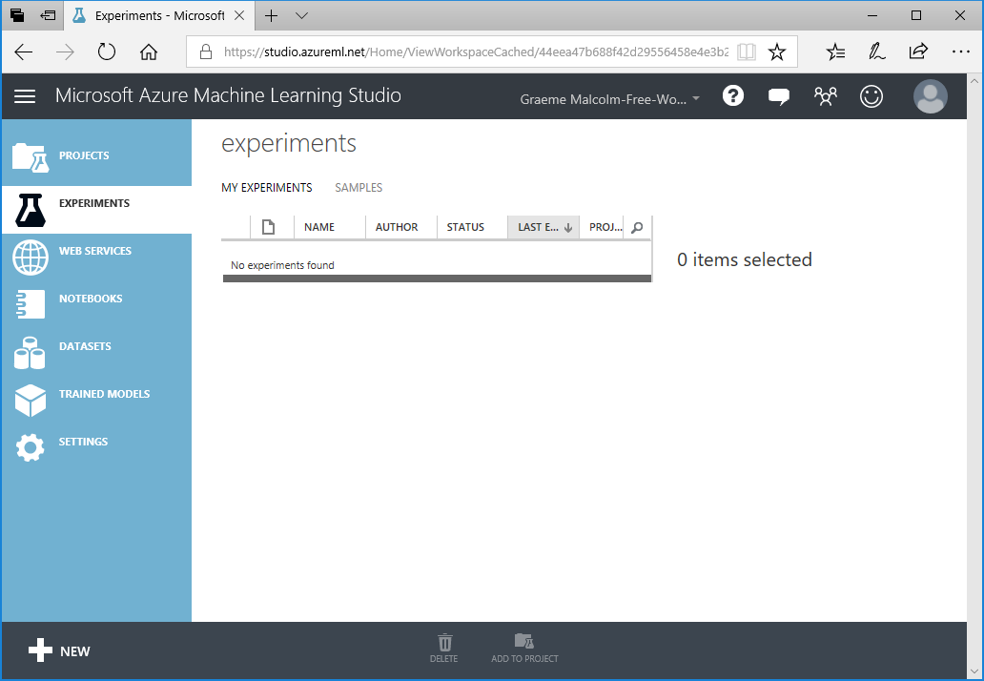

## Upload the Lemonade Dataset

1. In Azure Machine Learning Studio, click **DATASETS**. You should have no datasets of your own (clicking **Samples** will display some built-in sample datasets).
2. At the bottom left, click **+ NEW**, and ensure that the **DATASET** tab is selected.
3. Click **FROM LOCAL FILE**. Then in the **Upload a new dataset** dialog box, browse to select the **Lemonade.csv** file in the folder where you extracted the lab files on your local computer and enter the following details as shown in the image below, and then click the **(✓)** icon.

* **This is a new version of an existing dataset**: Unselected
* **Enter a name for the new dataset**: Lemonade.csv
* **Select a type for the new dataset**: Generic CSV file with a header (.csv)
* **Provide an optional description**: Lemonade sales data.

1. Wait for the upload of the dataset to be completed, then verify that it is listed under **MY DATASETS** and click the **OK (✓)** button to hide the notification.

The Lemonade.csv file contains the original lemonade sales data in comma-delimited format.

## Create an Experiment and Explore the Data

1. In Azure Machine Learning Studio, click **EXPERIMENTS**. You should have no experiments in your workspace yet.
2. At the bottom left, click **+ NEW**, and ensure that the **EXPERIMENT** tab is selected. Then click the **Blank Experiment** tile to create a new blank experiment.
3. At the top of the experiment canvas, change the experiment name to **Lemonade Training** as shown here:

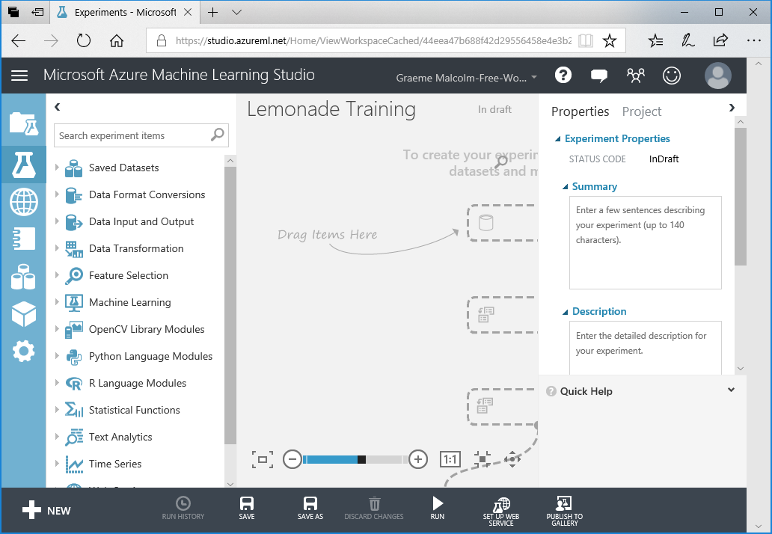

The experiment interface consists of a pane on the left containing the various items you can add to an experiment, a canvas area where you can define the experiment workflow, and a **Properties** pane where you can view and edit the properties of the currently selected item. You can hide the experiment items pane and the **Properties** pane by clicking the **<** or **>** button to create more working space in the experiment canvas.

1. In the experiment items pane, expand **Saved Datasets** and **My Datasets**, and then drag the **Lemonade.csv** dataset onto the experiment canvas, as shown here:

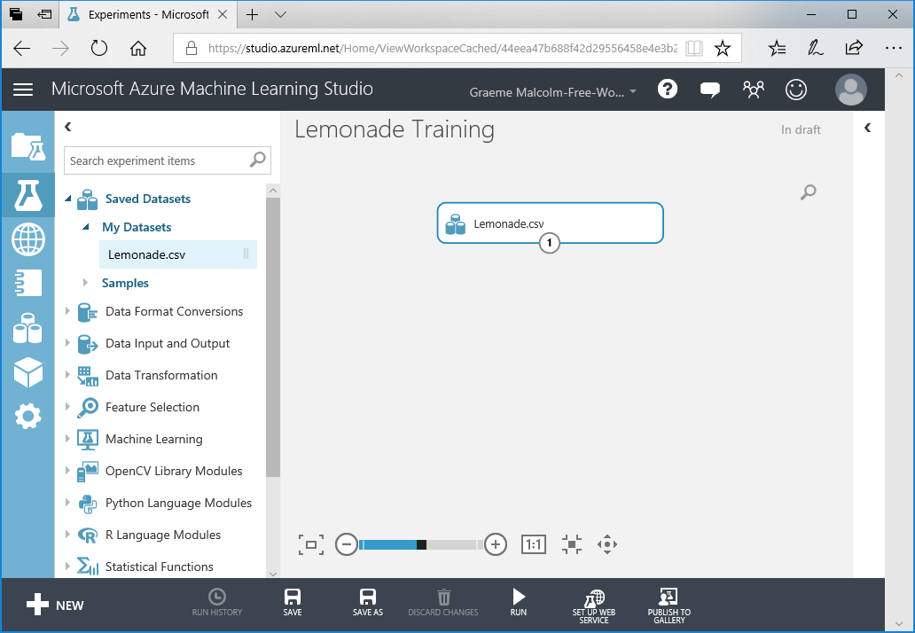

1. Right-click the dataset output of the **Lemonade.csv** dataset and click **Visualize** as shown here:

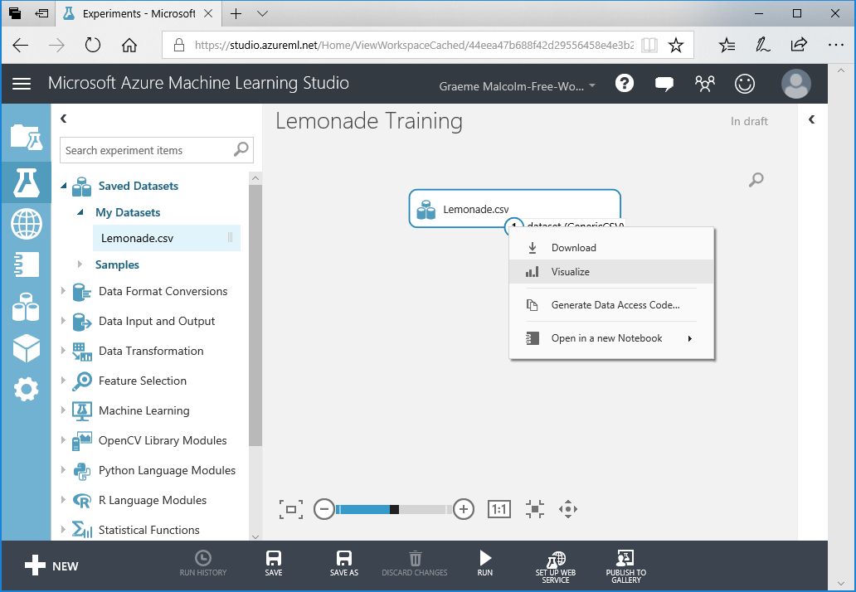

1. In the data visualization, note that the dataset includes a record, often referred to as an *observation* or *case*, for each day, and each case has mulitple characteristics, or *features* – in this example, the date, day of the week, temperature, rainfall, number of flyers distributed, and the price Rosie charged per lemonade that day. The dataset also includes the number of sales Rosie made that day – this is the *label* that ultimately you must train a machine learning model to predict based on the features.
2. Note the number of rows and columns in the dataset (which is very small – real-world datasets for machine learning are typically *much* larger), and then select the column heading for the **Temperature** column and note the statistics about that column that are displayed, as shown here:

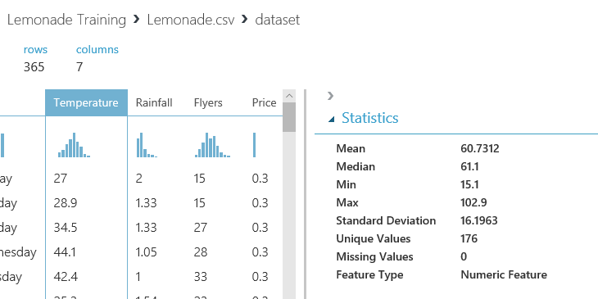

1. In the data visualization, scroll down if necessary to see the histogram for **Temperature**. This shows the distribution of different temperatures in the dataset:

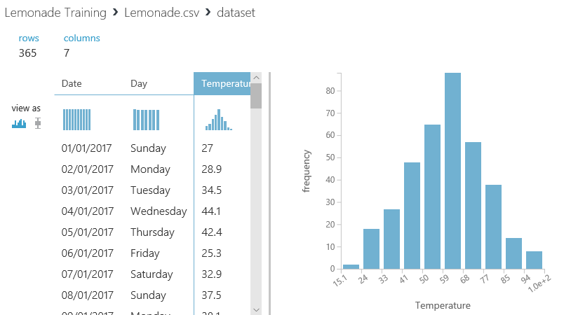

1. Click the **x** icon in the top right of the visualization window to close it and return to the experiment canvas.

## Explore Data in a Jupyter Notebook

Jupyter Notebooks are often used by data scientists to explore data. They consist of an interactive browser-based environment in which you can add notes and run code to manipulate and visualize data. Azure Machine Learning Studio supports notebooks for two languages that are commonly used by data scientists: R and Python. Each language has its particular strengths, and both are prevalent among data scientists. In this lab, you can use either (or both).

### To Explore Data using Python:

1. Right-click the **Lemonade.csv** dataset output, and in the **Open in a new Notebook** sub-menu, click **Python 3**. This opens a new browser tab containing a Jupyter notebook with two cells, each containing some code. The first cell contains code that loads the CSV dataset into a data frame named **frame**, similar to this:

from azureml import Workspace

ws = Workspace()

ds = ws.datasets['Lemonade.csv']

frame = ds.to_dataframe()

The second cell contains the following code, which displays a summary of the data frame:

frame

1. On the **Cell** menu, click **Run All** to run all of the cells in the workbook. As the code runs, the O symbol next to **Python 3** at the top right of the page changes to a ⚫ symbol, and then returns to O when the code has finished running.
2. Observe the output from the second cell, which shows some rows of data from the dataset, as shown here:

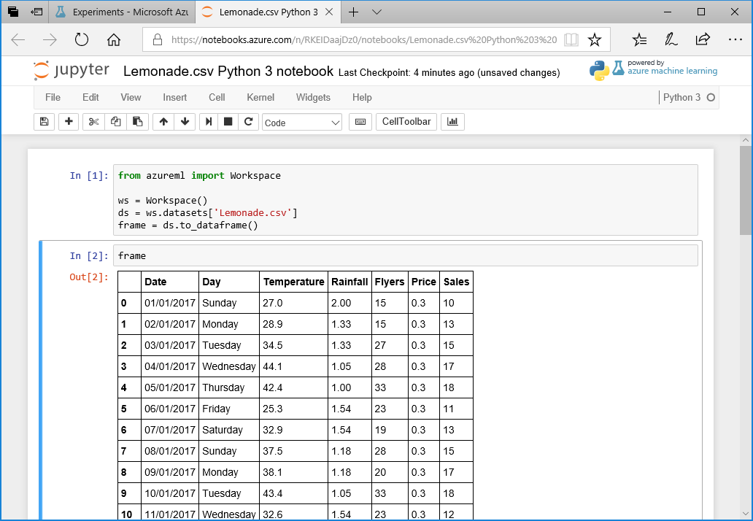

1. Click cell 2 (which contains the code frame), and then on the **Insert** menu, click **Insert Cell Below**. This adds a new cell to the notebook, under the output generated by cell 2.
2. Add the following code to the new empty cell (you can copy and paste this code from **Python.txt** in the folder where you extracted the lab files for this course):

%matplotlib inline

from matplotlib import pyplot as plt

# Print statistics for Temperature and Sales

print(frame[['Temperature','Sales']].describe())

# Print correlation for temperature vs Sales

print('\nCorrelation:')

print(frame['Temperature'].corr(frame['Sales']))

# Plot Temperature vs Sales

plt.xlabel('Temperature')

plt.ylabel('Sales')

plt.grid()

plt.scatter(frame['Temperature'],frame['Sales'])

plt.show()

1. With the cell containing the new code selected, on the **Cell** menu, click **Run Cells and Select Below** (or click the ▶**|** button on the toolbar) to run the cell, creating a new cell beneath.

**Note**: You can ignore any warnings that are generated.

1. View the output from the code, which consists of descriptive statistics for the **Temperature** and **Sales** columns, the correlation value for **Temperature** and **Sales**, and a scatterplot chart of **Temperature** vs **Sales** as shown here:

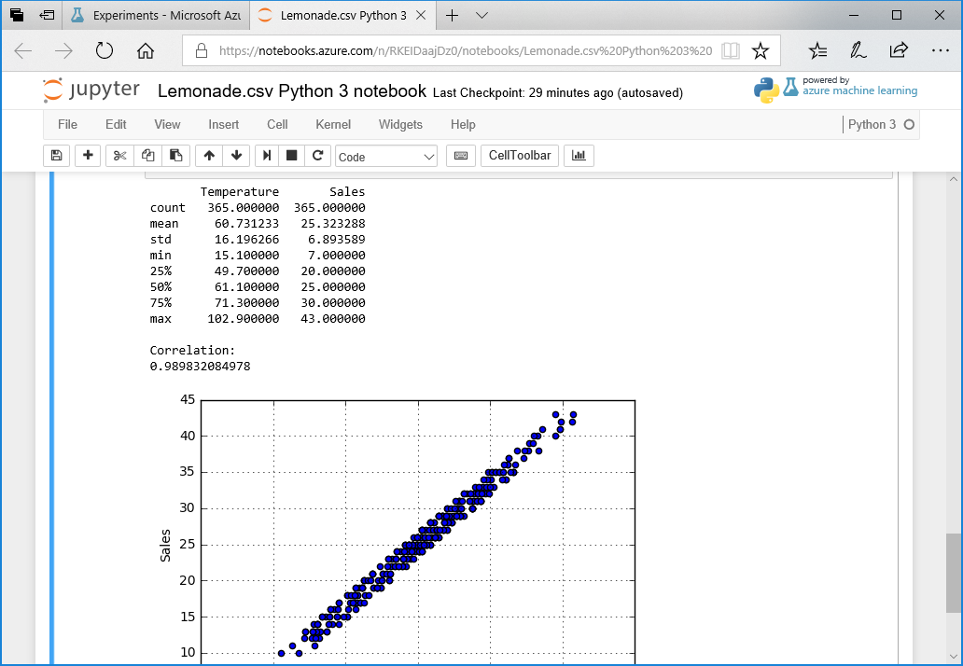

1. On the **File** menu, click **Close and Halt** to close the notebook and return to the experiment in Azure Machine Learning Studio.

### To Explore Data using R:

1. Right-click the **Lemonade.csv** dataset output, and in the **Open in a new Notebook** sub-menu, click **R**. This opens a new browser tab containing a Jupyter notebook with two cells, each containing some code. The first cell contains code that loads the CSV dataset into a data frame named **dat**, similar to this:

library("AzureML")

ws <- workspace()

dat <- download.datasets(ws, "Lemonade.csv")

The second cell contains the following code, which displays a summary of the data frame:

head(dat)

1. On the **Cell** menu, click **Run All** to run all of the cells in the workbook. As the code runs, the O symbol next to **R** at the top right of the page changes to a ⚫ symbol, and then returns to O when the code has finished running.
2. Observe the output from the second cell, which shows some rows of data from the dataset, as shown here:

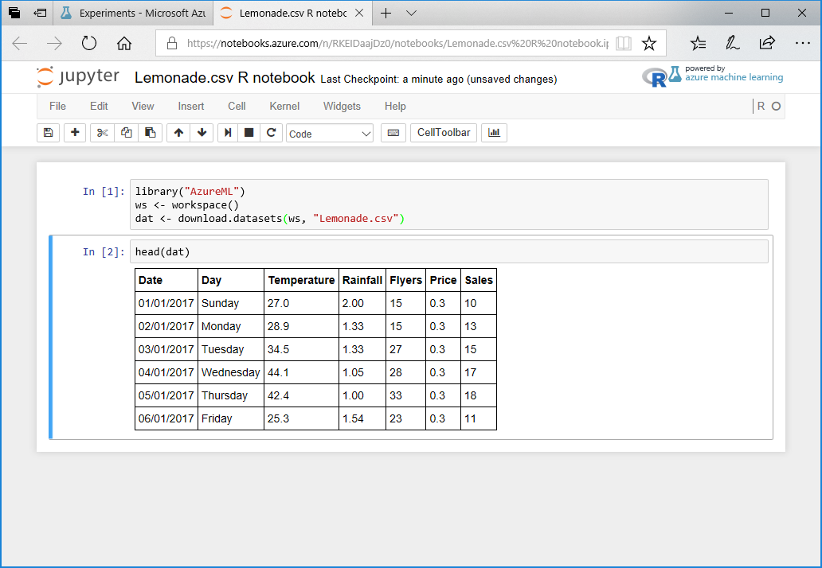

1. Click cell 2 (which contains the code head(dat)), and then on the **Insert** menu, click **Insert Cell Below**. This adds a new cell to the notebook, under the output generated by cell 2.
2. Add the following code to the new empty cell (you can copy and paste this code from **R.txt** in the folder where you extracted the lab files for this course):

# Print statistics for Temperature and Sales

summary(dat[c('Temperature', 'Sales')])

print('Standard Deviations:')

apply(dat[c('Temperature', 'Sales')],2,sd)

# Print correlation for temperature vs Sales

print('Correlation:')

cor(dat[c('Temperature', 'Sales')])

# Plot Temperature vs Sales

plot(dat$Temperature, dat$Sales, xlab="Temperature", ylab="Sales")

1. With the cell containing the new code selected, on the **Cell** menu, click **Run Cells and Select Below** (or click the ▶**|** button on the toolbar) to run the cell, creating a new cell beneath.
2. View the output from the code, which consists of descriptive statistics for the **Temperature** and **Sales** columns, the correlation matrix for **Temperature** and **Sales**, and a scatterplot chart of **Temperature** vs **Sales** as shown here:

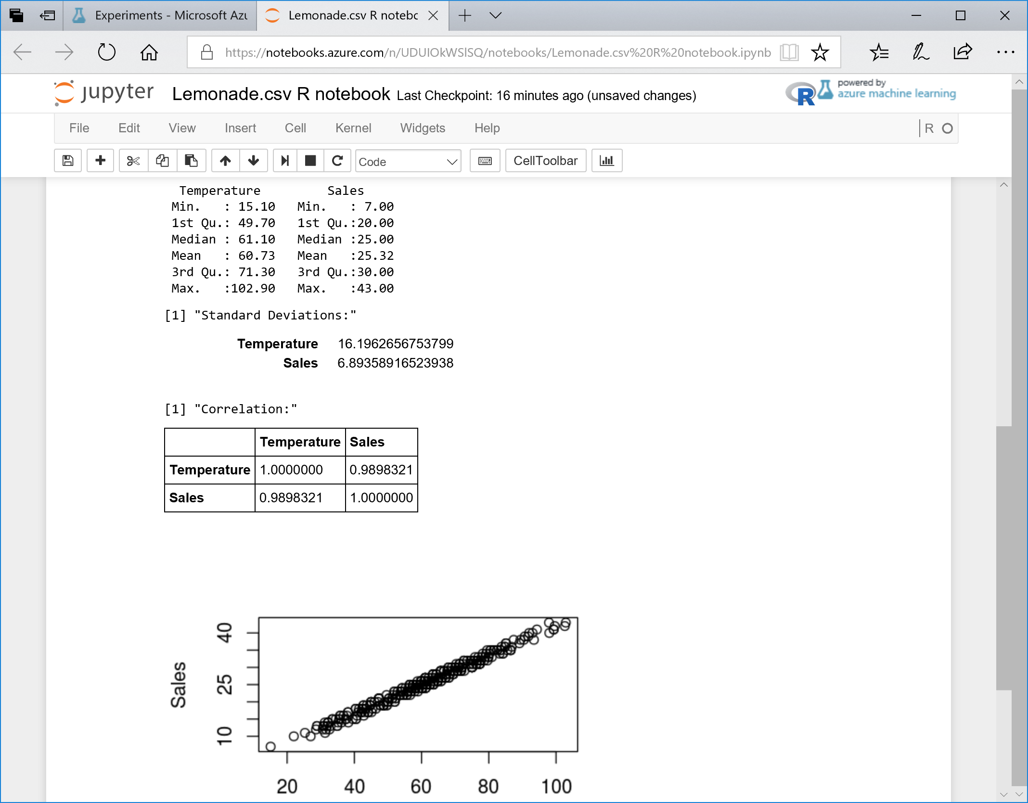

1. On the **File** menu, click **Close and Halt** to close the notebook and return to the experiment in Azure Machine Learning Studio.

## Prepare Data for Model Training

1. In the **Lemonade Training** experiment, visualize the output of the **Lemonade.csv** dataset and select the **Rainfall** column.
2. Under the statistics for this column, view the histogram and note that it is right-skewed:

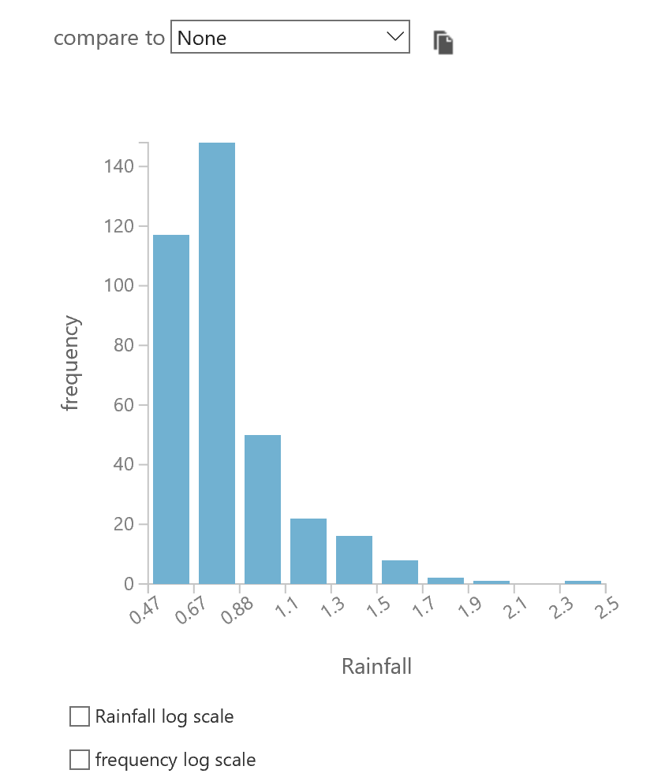

1. In the **compare to** drop-down list, select **Sales** and view the resulting scatterplot:

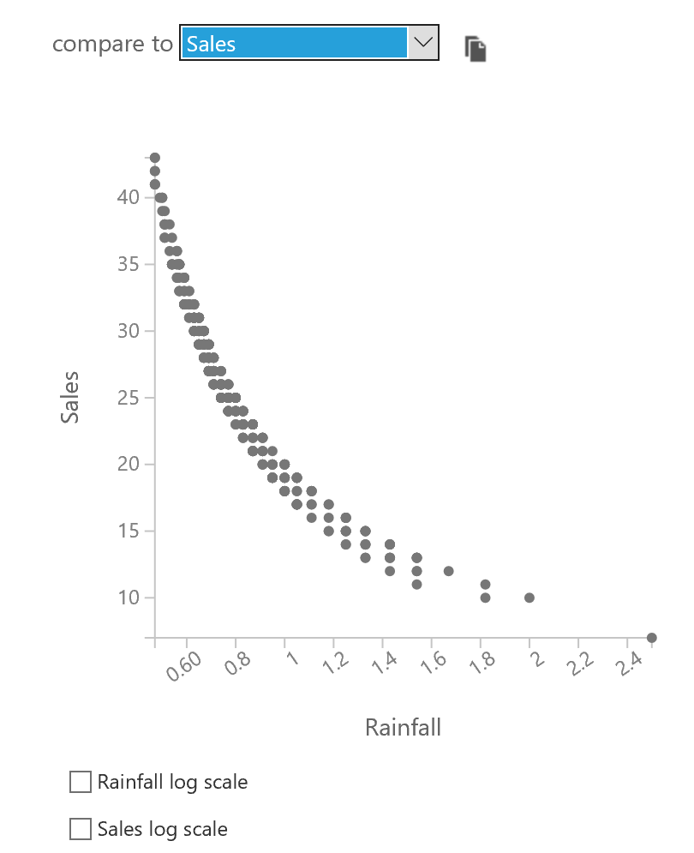

1. Note the curved nature of the relationship, and then select the **Rainfall** log scale checkbox and view the updated scatterplot:

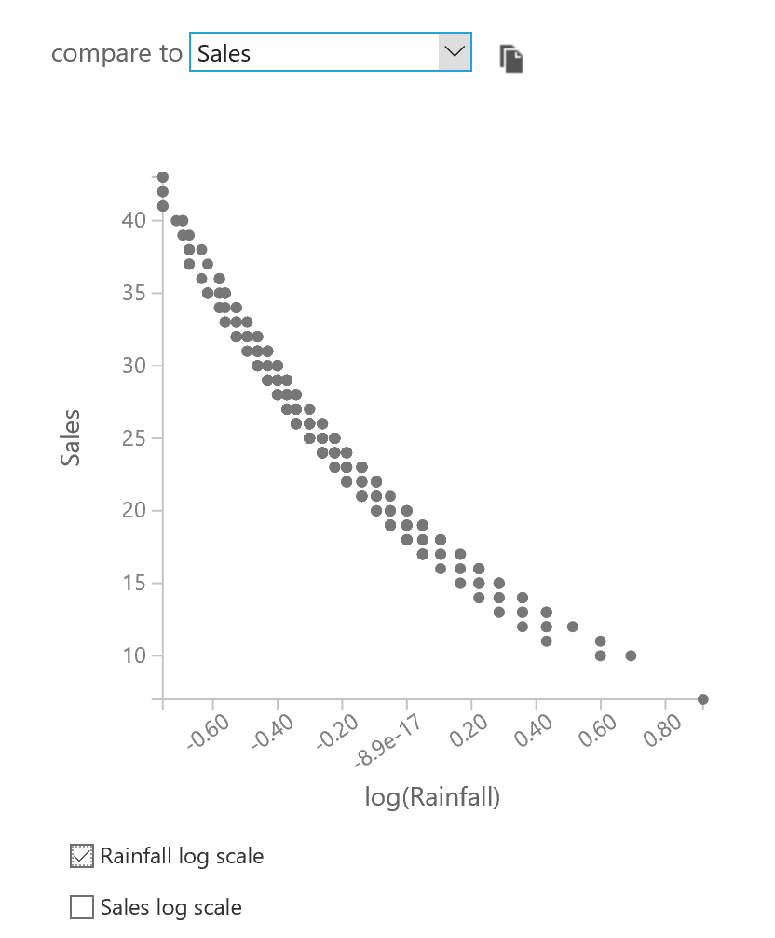

1. Note that this partially “straightens” the relationship to make it more linear; so converting **Rainfall** to its natural log may make it easier to define a linear function that relates these columns. Using the log scale for **Sales** would straighten it even more, but since **Sales** already has a linear relationship with other columns (as we saw with **Temperature** in the notebook visualizations), it may be best to leave that column as it is.
2. Close the visualization.
3. In the Search experiment items box, enter **Math**. Then drag the **Apply Math Operation** module onto the canvas, under the **Lemonade.csv** dataset, and connect the output of the **Lemonade.csv** dataset to the **Apply Math Operation** module as shown here:

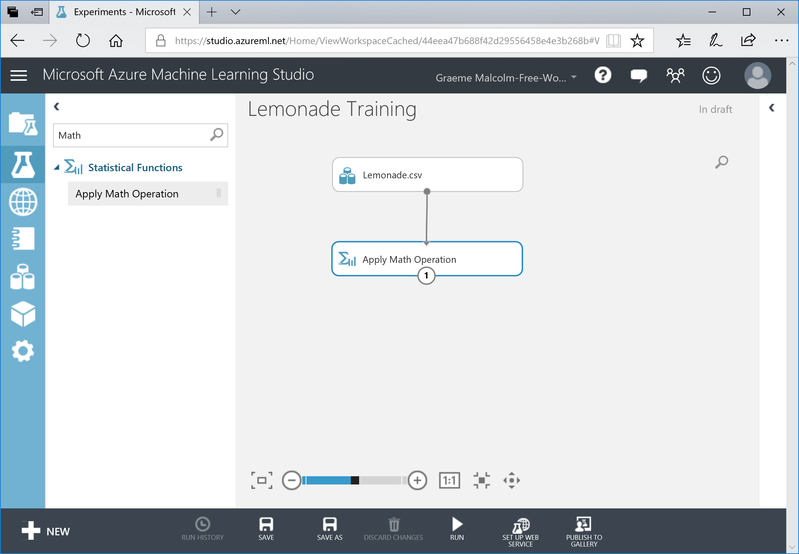

1. With the **Apply Math Operation** module selected, in the **Properties** pane, select the **Basic** category and the **Ln** basic function as shown here:

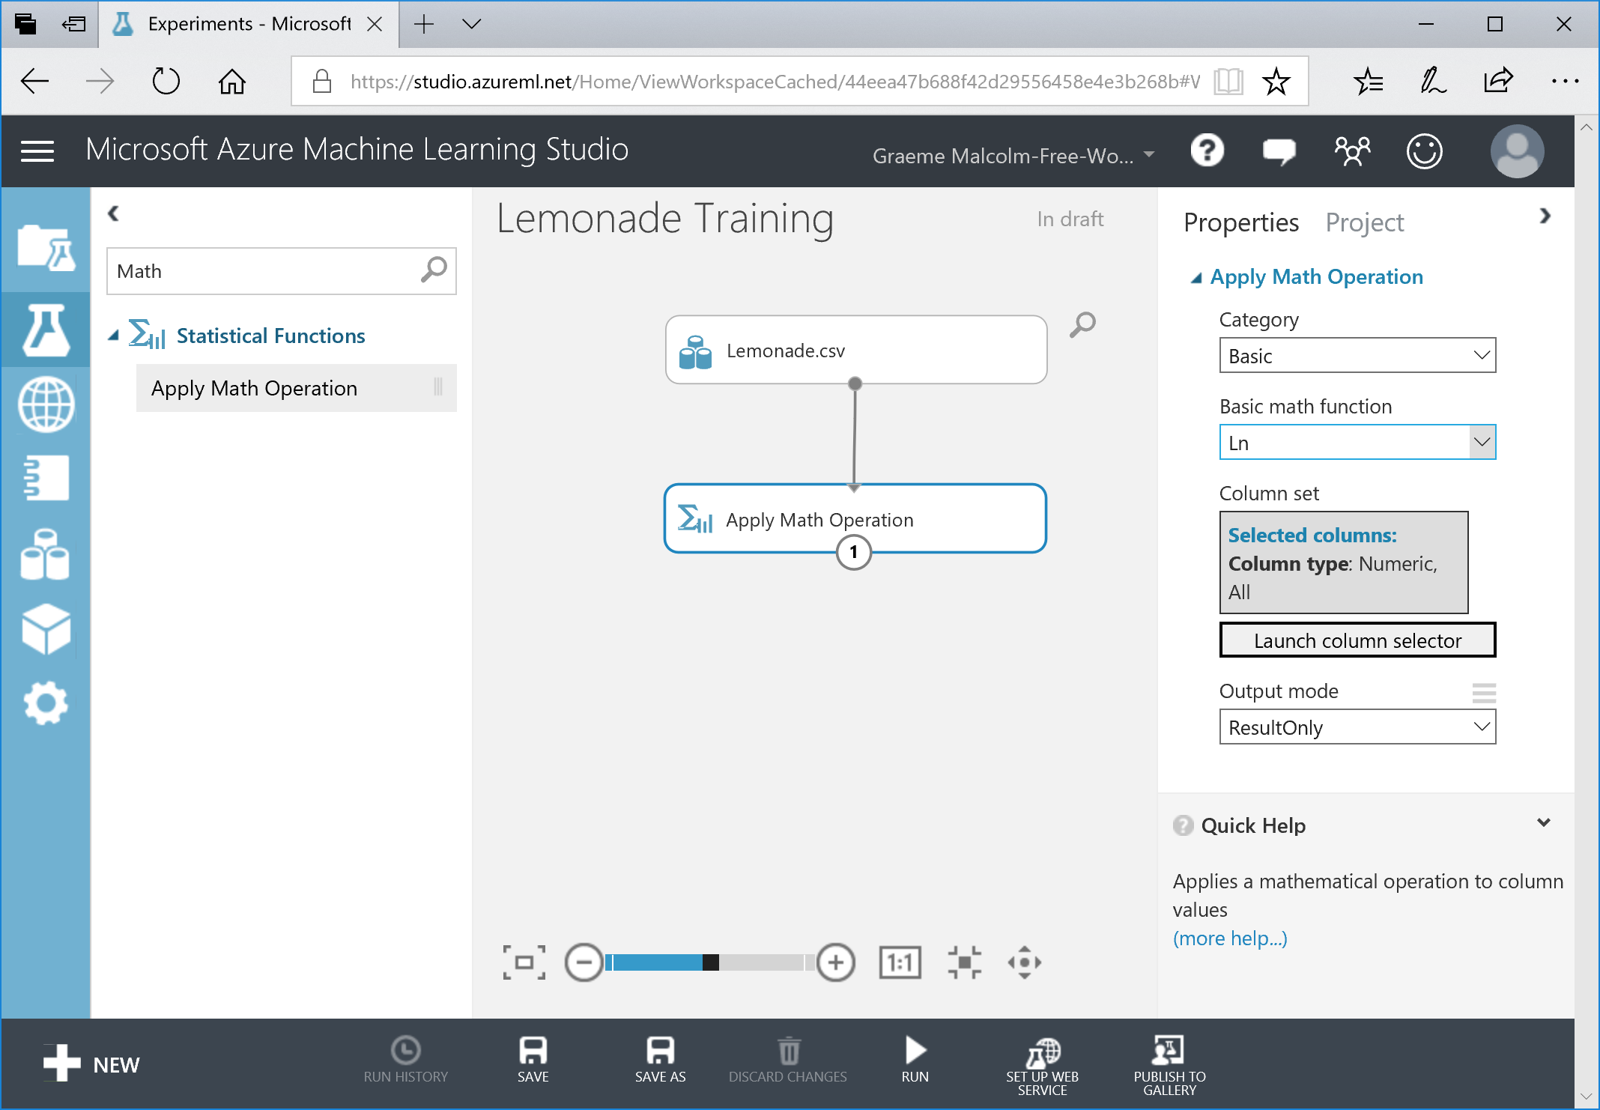

1. In the **Properties** pane, click **Launch column selector**, and then in the column selector, on the **By Name** tab, move all columns other than **Rainfall** to the left so that only the Rainfall column is listed in the **Selected columns** list as shown here. Then click **(✓)**.

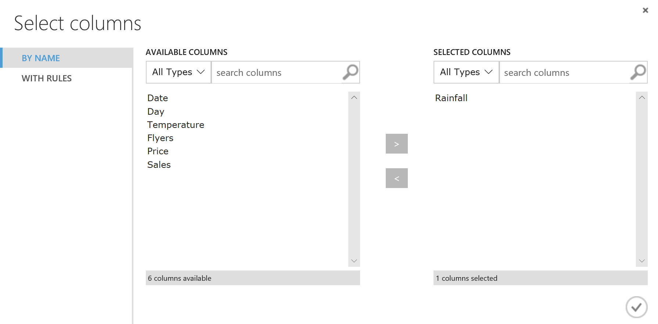

1. In the **Properties** pane, in the **Output mode** list, select **Inplace** as shown below, so that the existing **Rainfall** column is replaced with its natural log.

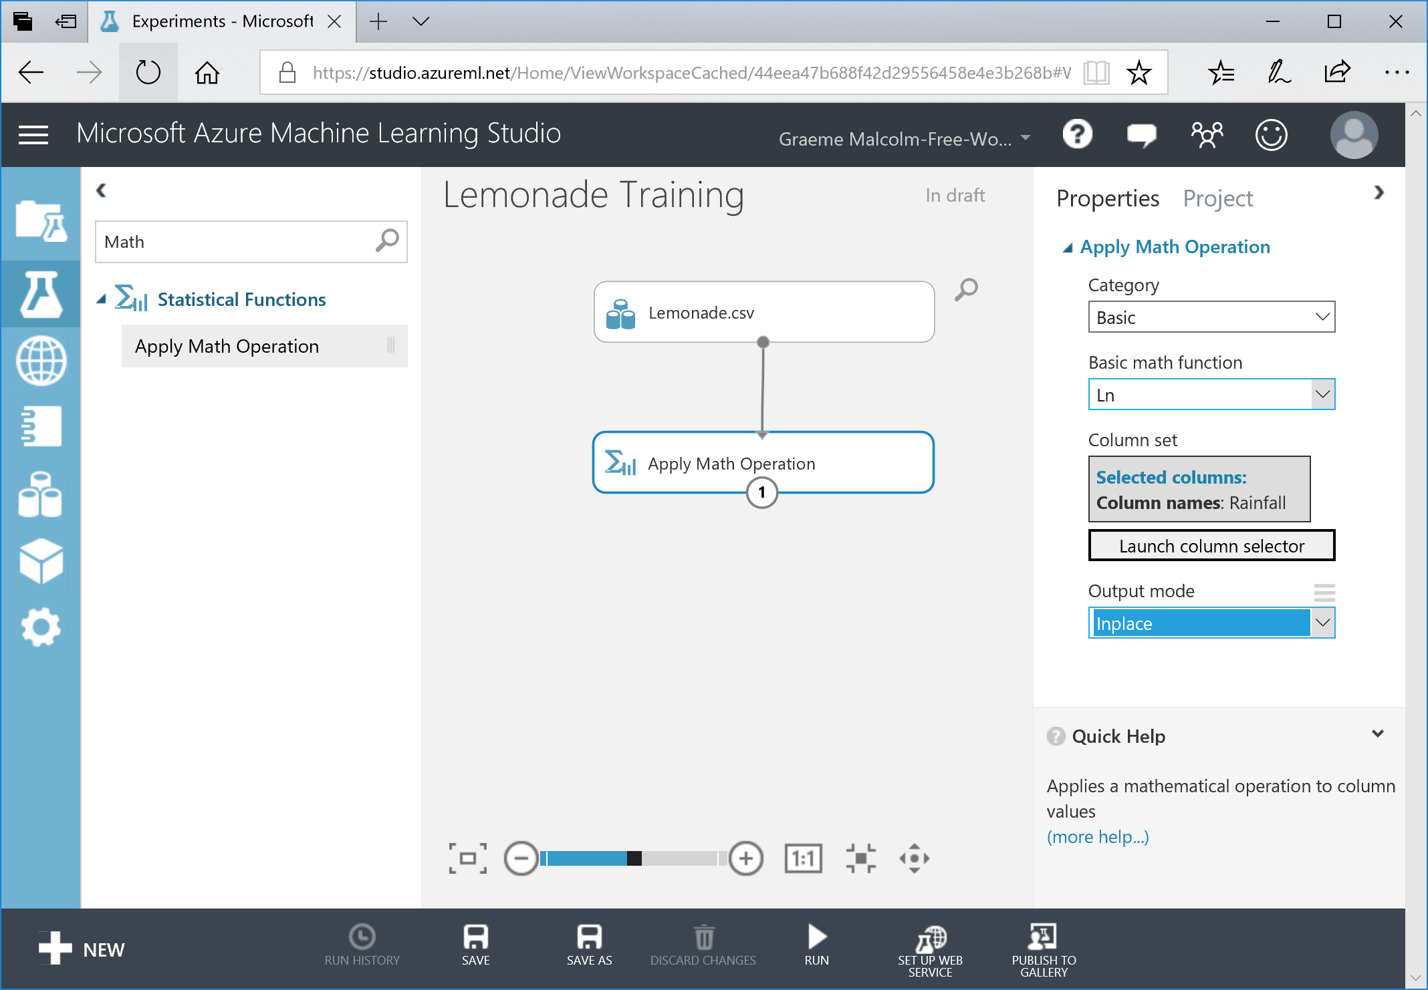

1. At the bottom of the page, click the **Run** (▷) button to run the experiment so far. Wait for the experiment to finish running. A green **✓** icon in the **Apply Math Operation** module indicates that it has run.
2. Visualize the output of the **Apply Math Operation** module and select the **Rainfall** column. Then compare the visualization of this column with **Sales** as you did before, and verify that the default relationship is straighter without selecting the log scale:

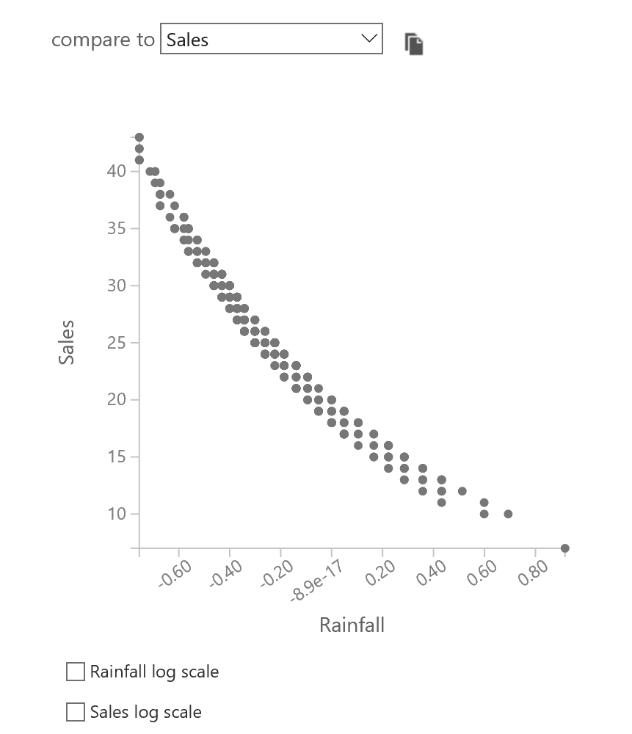

1. In the **compare to** drop-down list, select **Temperature**, and view the relationship between rainfall and temperature:

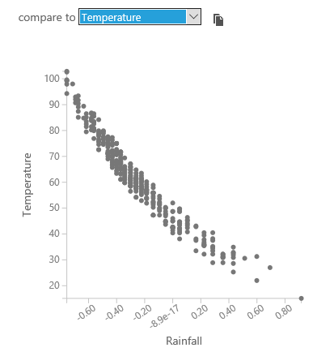

Take a close look at the scale on each axis. Temperatures range from 0 to over 100, while the log of rainfall is fractional between 0 and 0.8. If you were to compare all of the features in the dataset, you’d find that there is some disparity between the scales of values – for example, the number of flyers distributed ranges from 9 to 80, but the price of a lemonade ranges from 0.3 to 0.5. When training a machine learning model, features with larger scales of value can dominate features on smaller scales; so it’s generally useful to *normalize* the numeric features so that they are on a similar scale while maintaining the correct proportional distances between values for any given feature. We’ll do this next.

1. Close the visualization and return to the experiment canvas.
2. In the **Search experiment items** box, type **Normalize**, and then drag a **Normalize Data** module to the canvas and connect it to the output from the **Apply Math Operation** module as shown here:

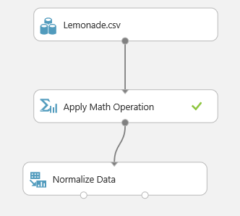

1. Configure the **Normalize Data** module properties as follows:
   * **Transformation method**:ZScore
   * **Use 0 for constant columns when checked**: Checked
   * **Selected columns**: Temperature and Flyers

ZScore normalization works well for numeric features that have an approximately *normal* distribution.

1. Select the **Normalize Data** module and on the **Run** menu, click **Run Selected** to run the data flow.
2. After the experiment has been run, add a second **Normalize Data** module to the experiment, and connect the **Transformed dataset** (left) output of the first **Normalize Data** module to its input as shown here:

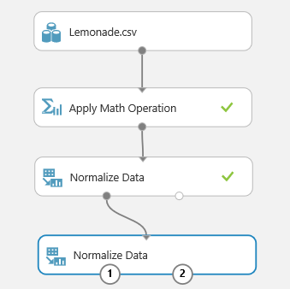

1. Configure the new **Normalize Data** module as follows
   * **Transformation method**:MinMax
   * **Use 0 for constant columns when checked**: Checked
   * **Selected columns**: Rainfall and Price

MinMax normalization works well for features that are not normally distributed.

1. Run the experiment.
2. Visualize the **Transformed Dataset** (left) output of the last **Normalize Data** module and view the **Temperature**, **Rainfall**, **Flyers**, and **Price** columns. These have all been normalized so that the values are of a similar scale, while maintaining the proportional distributions within each feature:

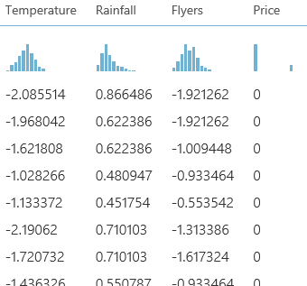

1. Close the visualization and return to the experiment canvas.

## Train a Regression Model

1. Search for the **Edit Metadata** module, add one to the experiment, and connect the **Transformed dataset** (left) output of the second **Normalize Data** module to its input as shown here:

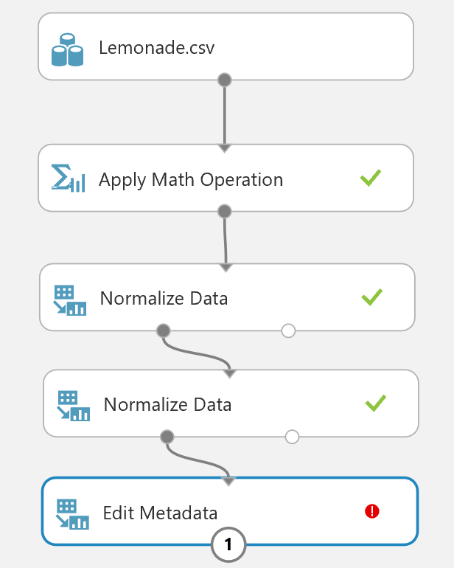

1. Configure the properties of the **Edit Metadata** module as follows:
   * **Selected columns**: Date, Day, and Sales
   * **Data type**: Unchanged
   * **Categorical**: Unchanged
   * **Fields**: Clear feature
   * **New column names**: *leave blank*

The **Date** and **Day** columns aren’t likely to help predict sales volumes, and **Sales** column is the label the model will predict; so these fields should not be used as features to train the model.

1. Search for the **Split Data** module, add one to the canvas, and connect the **Results dataset** output of the **Edit Metadata** module to its input as shown here:

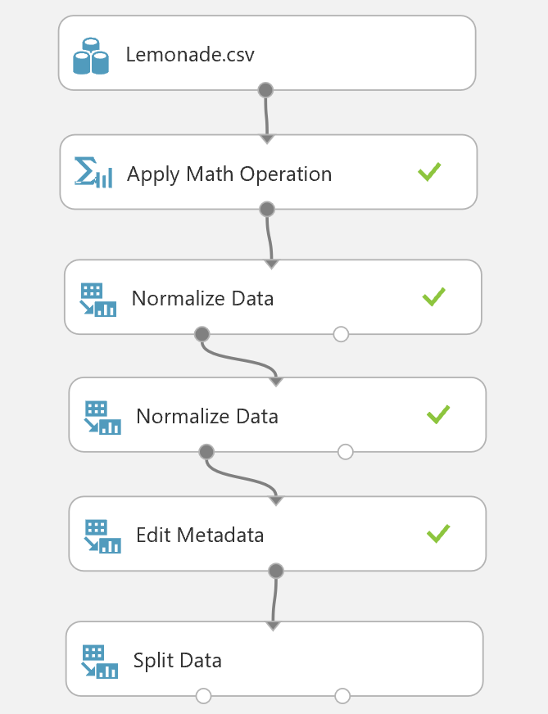

1. Configure the **Split Data** module properties as follows:
   * **Splitting mode**: Split Rows
   * **Fraction of rows in the first output dataset**: 0.7
   * **Randomized split:** Checked
   * **Random seed**: 0
   * **Stratified split**: False

You are going to train a regression model, which is a form of *supervised* learning that predicts numeric values. When training a supervised learning model, it is standard practice to split the data into a training dataset and a test dataset, so that you can validate the trained model using test data that contains the actual label values the model is being trained to predict. In this case, you are going to use 70% of the data to train the model while withholding 30% of the data with which to test it.

1. Select the **Split Data** module, and on the **Run** menu, click **Run selected**.
2. In the **Search experiment items** box, type **Linear Regression**, and then draga **Linear Regression** module to the canvas, to the left of the **Split Data** module.
3. In the **Search experiment items** box, type **Train Model**, and then draga **Train Model** module to the canvas, under the **Linear Regression** and **Split Data** modules.
4. Connect the **Untrained Model** output of the **Linear Regression** module to the **Untrained Model** (left) input of the **Train Model** module. Then connect the **Result dataset1** (left) output of the **Split Data** module to the **Dataset** (right) input of the **Train Model** module as shown here:

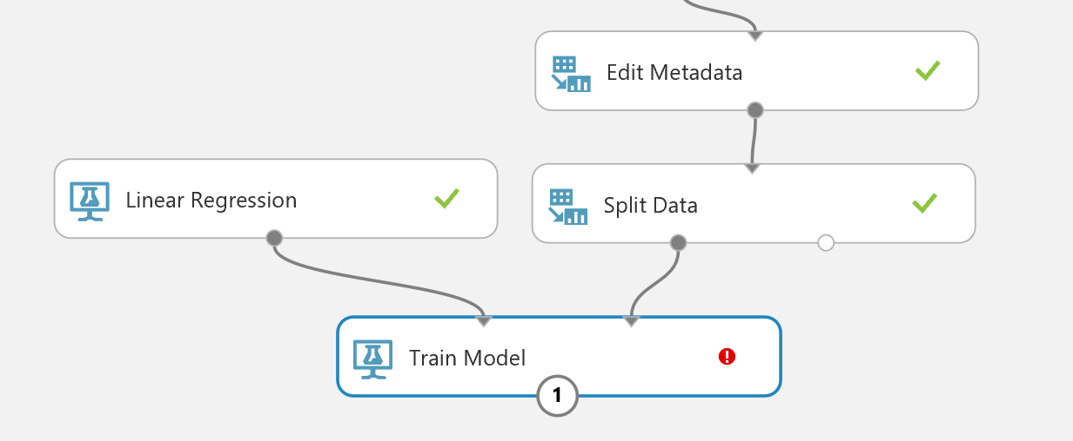

1. Select the **Linear Regression** module and review its default properties. These parameters are used to *regularize* the training of the model – that is, minimize bias so that the model generalizes well when used with new data.
2. Select the **Train Model** module and use the column selector to select the **Sales** column – this is the label that the model will be trained to predict.
3. In the **Search experiment items** box, type **Score Model**, and then draga **Score Model** module to the canvas, under the **Train Model** module.
4. Connect the **Trained model** output of the **Train Model** module to the **Trained model** (left) input of the **Score Model** module. Then connect the **Results dataset2** (right) output of the **Split Data** module to the **Dataset** (right) input of the **Score Model** module as shown here:

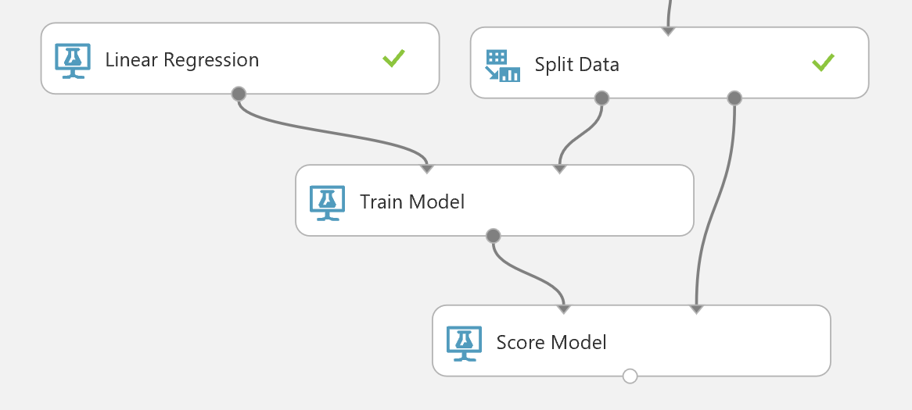

The **Score Model** module applies the trained model to the withheld test dataset, predicting a scored label (in this case, the number of sales).

1. In the **Search experiment items** box, type **Evaluate Model**, and then dragan **Evaluate Model** module to the canvas, under the **Score Model** module. Then connect the **Scored dataset** output of the **Score Model** module to its **Scored dataset** (left) input as shown here:

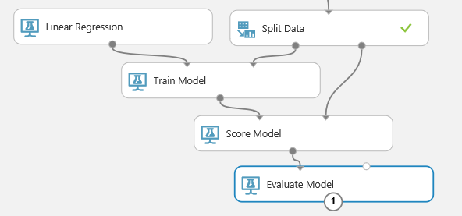

The **Evaluate Model** module compares the scored label prediction to the actual label value in the withheld test dataset (in this case **Sales**) and calculates a range of metrics that can be used to evaluate how accurately the model has predicted the labels.

1. Run the experiment and wait for it to complete.
2. When the experiment has completed, visualize the output of the **Scored Model** module and select the **Scored Labels** column header. This column contains the sales predicted by the model.
3. View the histogram for the **Scored Labels** column, and in the **compare to** list, select **Sales** to see a scatterplot of predicted sales against actual sales:

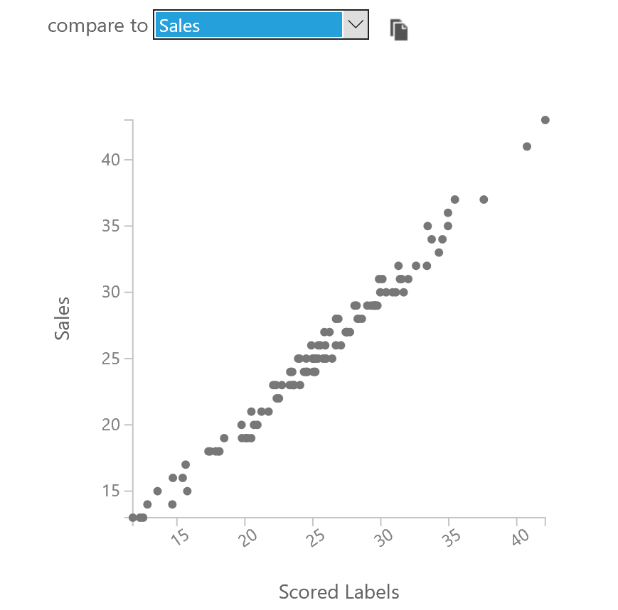

1. The scatterplot shows a fairly straight diagonal line, indicating that the predicted sales match the actual sales fairly closely.
2. Close the visualization, and then visualize the output of the **Evaluate Model** module.
3. Review the metrics for the model, which should resemble this:

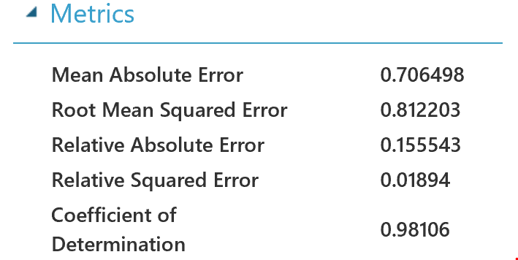

Mean Absolute Error (MAE) and Root Mean Square Error (RMSE) are metrics that measure the *residuals* (the variance between predicted and actual values) in the same units as the label itself – in this case the number of sales. Both of these metrics indicate that on average, the model is accurate within one sale.

Relative Absolute Error (RAE) and Relative Squared Error (RSE) are relative measures of error. The closer these values are to zero, the more accurately the model is predicting.

Coefficient of Determination, sometimes known as R-Squared, is another relative measure of accuracy; but this time, the closer it is to 1, the better the model is performing.

Overall, it looks like the model is performing well.

**Note**: In reality, most models are not immediately this accurate – it usually takes several iterations to determine the best features to use in the model. Additionally, just because the model performs well with the test data, that doesn’t mean it will generalize well with new data – it may be *overfitted* to the training dataset. There are techniques that data scientists use to validate models and avoid overfitting, which we don’t have time to cover in this introductory course.

1. Close the visualization and return to the experiment canvas.

# Exercise 2: Publishing and Using a Machine Learning Model

Now that you have trained a machine learning model, you can publish it as a web service and use it to predict labels from new feature data. In Azure Machine Learning Studio, you do this by creating a *predictive experiment* that encapsulates your model and the data preparation steps you have defined, and which defines the input and output interfaces through which features are passed into the model and predicted labels are returned. You then publish this predictive experiment as a web service in Azure.

## Create a Predictive Experiment

1. In the **Lemonade Training** experiment, on the toolbar under the experiment canvas, click the **Set Up Web Service** icon and click **Predictive Web Service [Recommended]**. Then wait for the predictive experiment to be created and click **Close ⮾** to close the notification.
2. In the **Predictive Experiment** tab, change the experiment name from **Lemonade Training [Predictive Exp.]** to **Predict Lemonade Sales**. Then rearrange the modules in the predictive experiment like this:

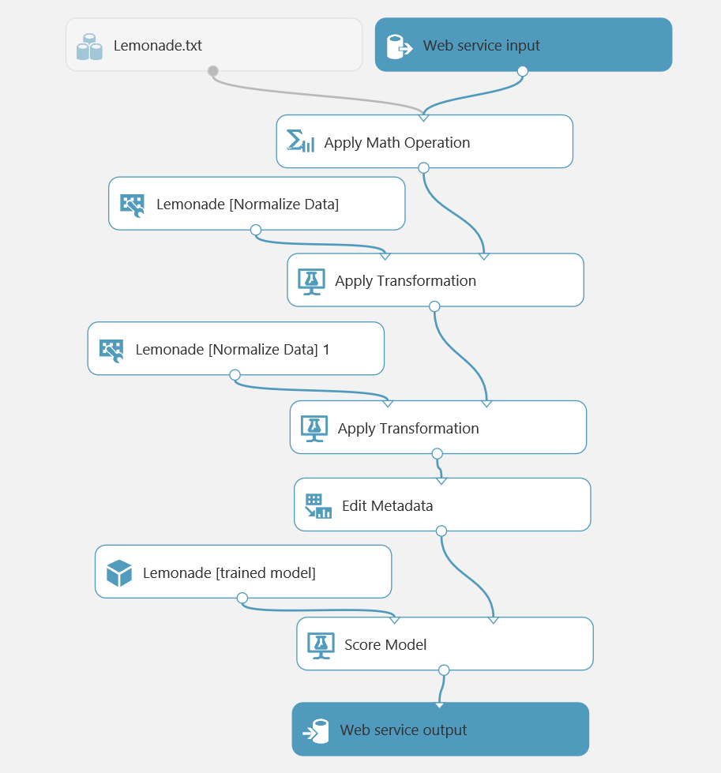

The experiment consists of:

* A web service input with a schema defined by the original **Lemonade.csv** training dataset.
* The **Apply Math** operation to replace **Rainfall** with its natural log.
  + An **Apply Transformation** module that normalizes the **Temperature** and **Flyers** features using the ZScore statistics from the training data.
  + An **Apply Transformation** module that normalizes the **Rainfall** and **Price** features using the MinMax statistics from the training data.
  + An **Edit Metadata** module that clears the **Day**, **Date**, and **Sales** features.
  + A **Score Model** module that predicts the scored label from the input data by applying the rained model.
  + A web service output that returns the results to the calling application.

1. Delete the **Lemonade.csv** dataset, then search for an **Enter Data Manually** module, add it to the top of the experiment, and connect its output to the input of the **Apply Math Operation** like this:

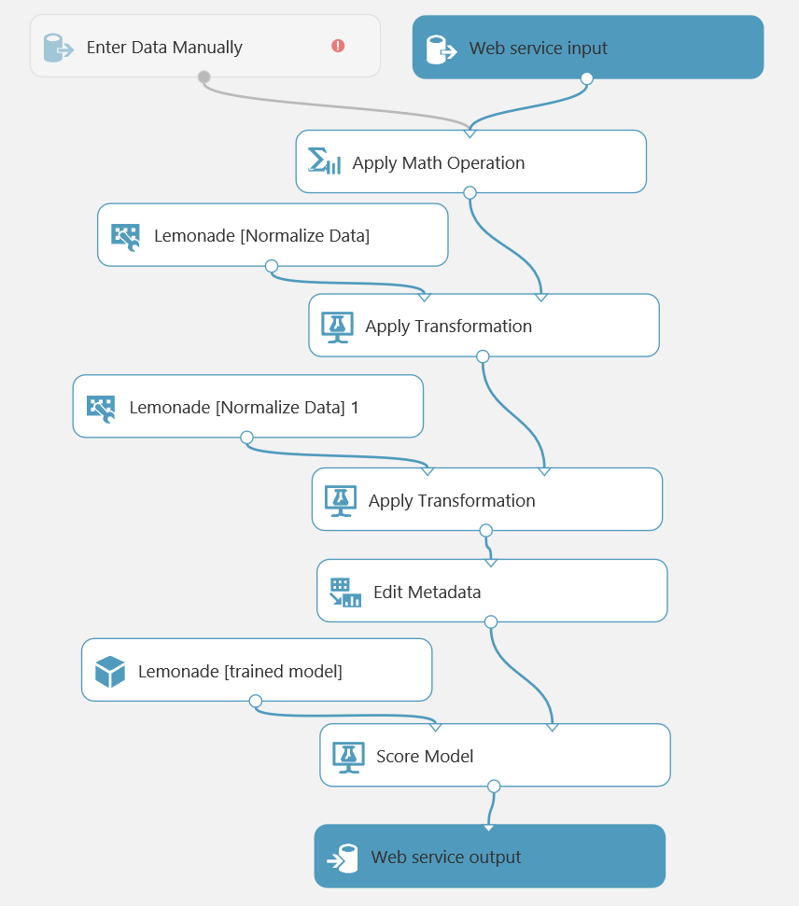

The **Lemonade.csv** dataset included the **Sales** field, which is what the model predicts. It therefore makes sense to redefine the input schema for the web service so that the **Sales** field is not submitted.

1. Select the **Enter Data Manually** module, and in the **Properties** pane, ensure **DataFormat** is set to **CSV** and **HasHeader** is selected, and then enter the following test data (which you can copy and paste from **Input.txt** in the folder where you extracted the lab files):

Date,Day,Temperature,Rainfall,Flyers,Price

01/01/2017,Sunday,27,2.00,15,0.3

02/01/2017,Monday,28.9,1.33,15,0.3

03/01/2017,Tuesday,34.5,1.33,27,0.3

04/01/2017,Wednesday,44.1,1.05,28,0.3

1. Select the **Edit Metadata** module and edit its properties to launch the column selector and remove the **Sales** field – this field no longer exists in the input dataset, so referencing it here will cause a runtime error when the web service is called.
2. Run the experiment.
3. Visualize the output from the **Score Model** module, and note that it includes all of the fields from the input data you entered manually along with the scored labels.

Client applications calling the web service only require the scored labels, so you can modify the output schema to remove the other fields.

1. Select the connection between the **Score Model** and **Web service output**, and delete it.
2. Search for and add an **Apply SQL Transformation** module, connecting it to the dataflow between the Score Model and Web service output modules like this:

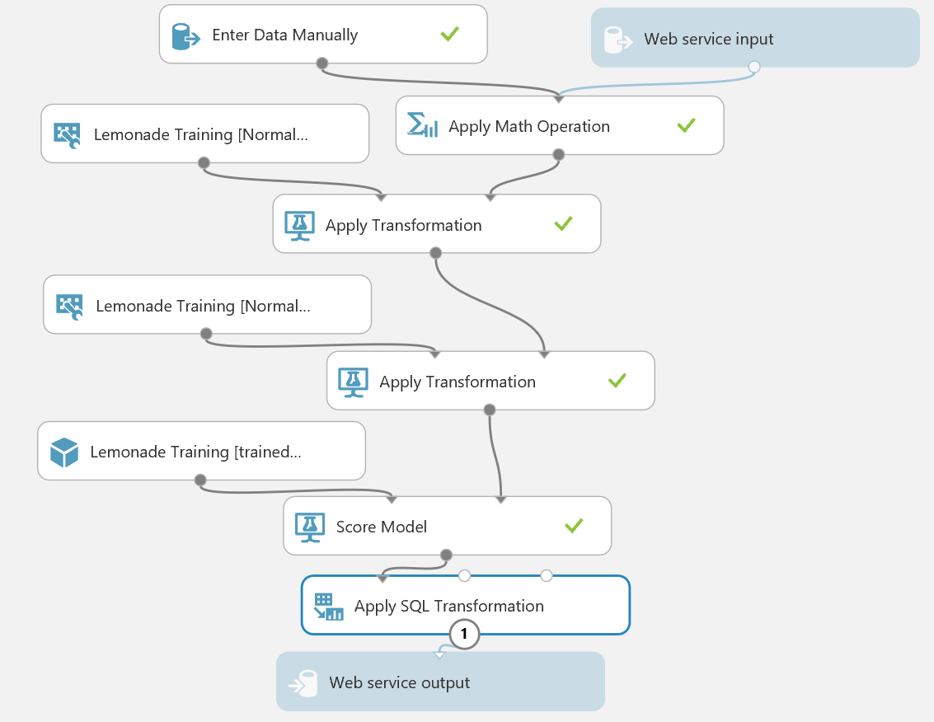

1. Modify the properties of the **Apply SQL Transformation** module to replace the default SQL Query Script with the following code (which you can copy and paste from **Output.txt**):

SELECT [Scored Labels] AS PredictedSales

FROM t1;

1. Run the experiment.
2. Visualize the output of the **Apply SQL Transformation** module and verify that only the **PredictedSales** column is now returned.

## Deploy the Web Service

1. At the bottom of the experiment canvas, click **Deploy Web Service**, and wait for the web service to be deployed.
2. In the **predict lemonade sales** web service page, click the **New Web Services Experience** link, which opens a new tab with the Azure Machine Learning Web Services Management portal as shown here:

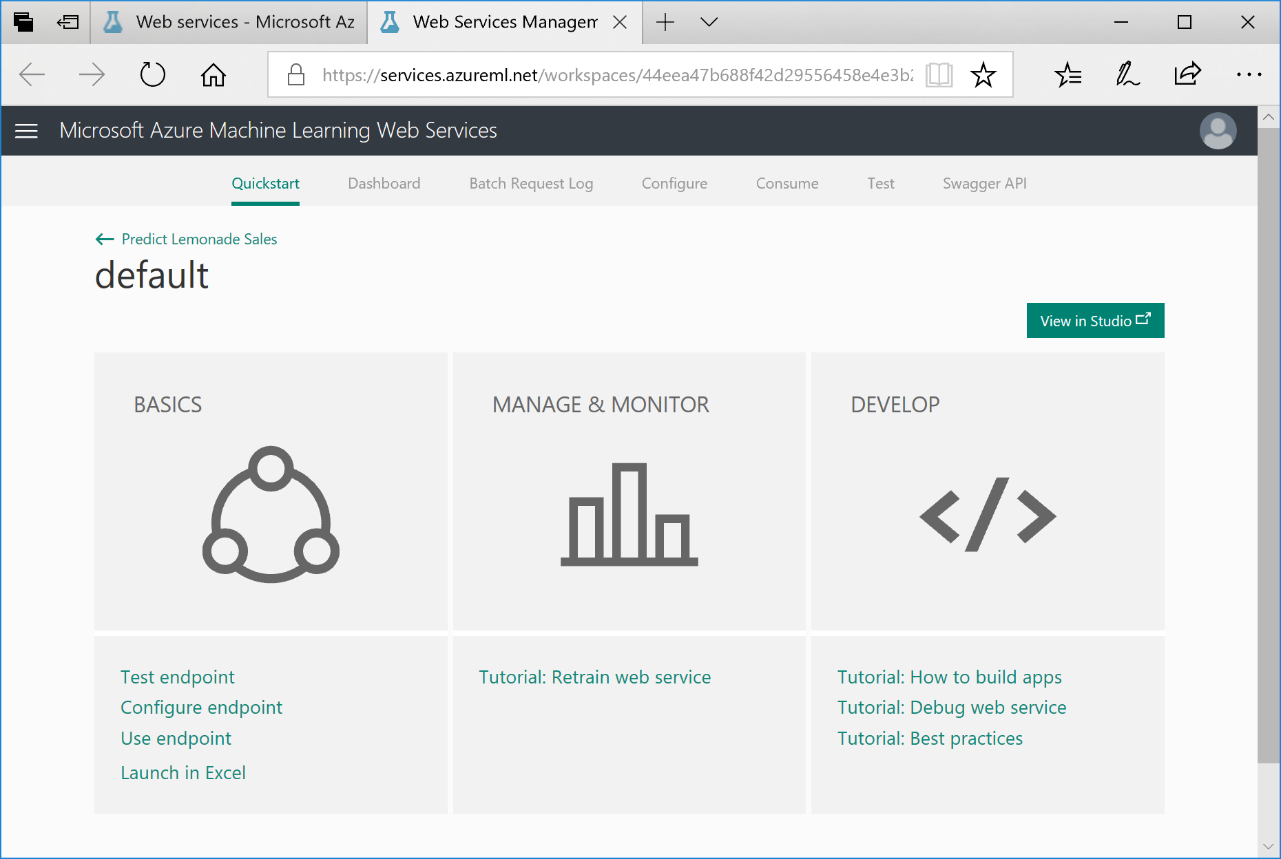

1. Click the **Consume** tab, and note that this page contains the keys and endpoint URLs that are used by a client application to call the web service. You will use these settings in the next procedure to call the web service from Excel Online.

## Consume the Web Service

1. In a new browser tab, navigate to <https://office.live.com/start/Excel.aspx> and sign in using your Microsoft credentials.
2. Create a new blank workbook.
3. On the Insert tab of the ribbon, click **Office Add-ins**, and on the **Store** tab, search for **Azure Machine Learning** as shown here:

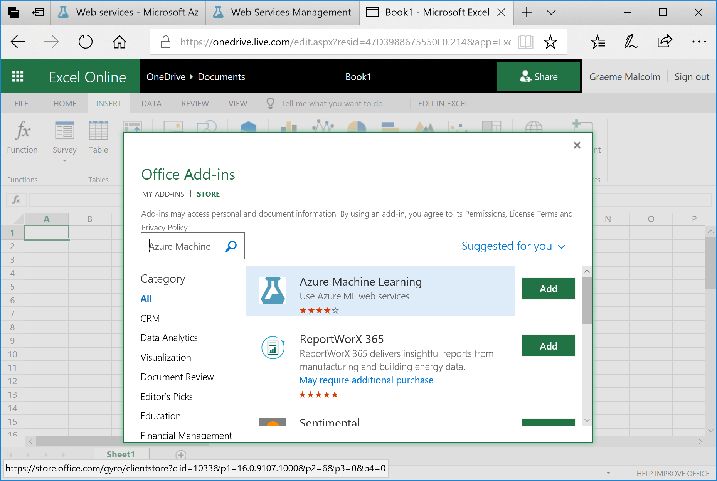

1. Add the **Azure Machine Learning** add-in. This opens the **Azure Machine Learning** tab in Excel like this:

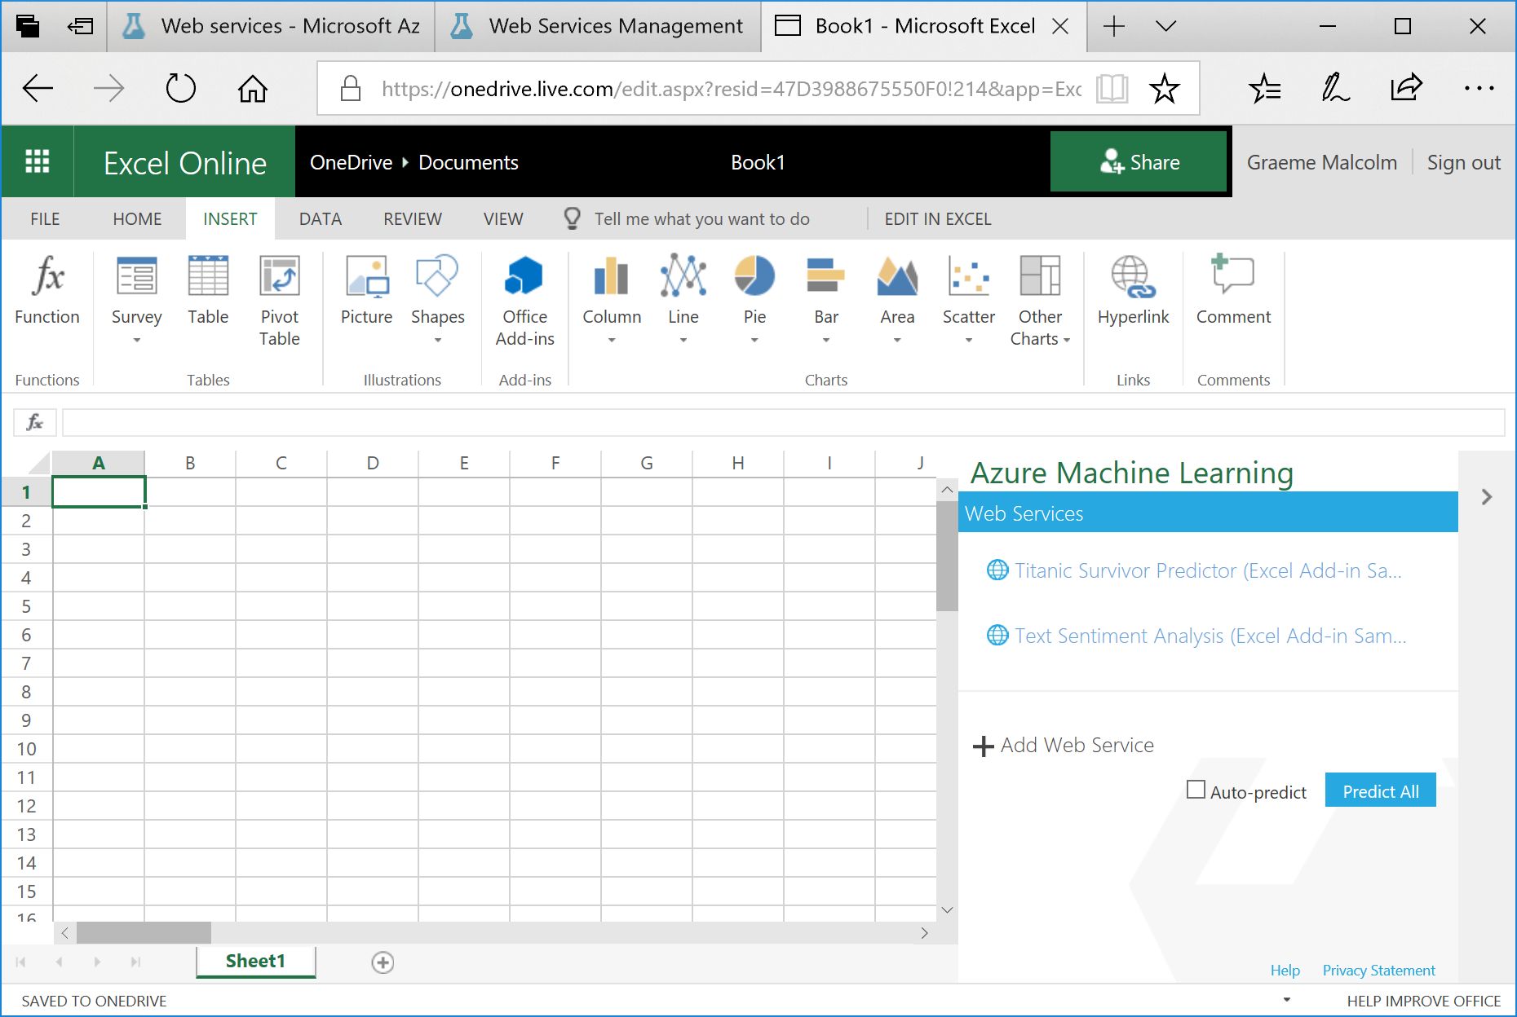

The add-in includes links for some built-in sample web services, but you will add your own web service.

1. Click 🞥 **Add Web Service**.
2. Switch back to the Web Services Management tab in your browser, and copy the **Request-Response** URL to the clipboard. Then return to the Excel Online tab and paste the copied URL into the **URL** textbox of the Azure Machine Learning pane as shown here:

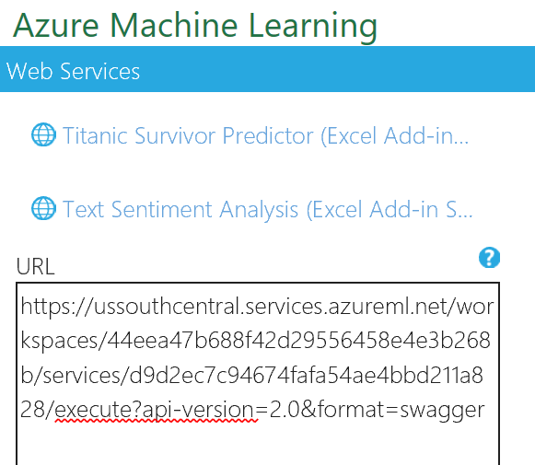

1. Switch back to the Web Services Management tab in your browser, and copy the **Primary Key** to the clipboard. Then return to the Excel Online tab and paste the copied key into the **API key** textbox of the Azure Machine Learning pane as shown here:

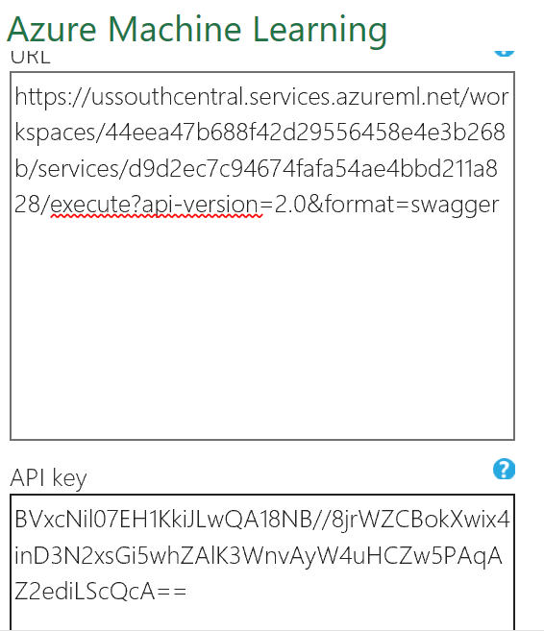

1. Click **Add** to add the web service.
2. Starting in cell A1, enter the following data in the worksheet:

|  |  |  |  |  |  |  |
| --- | --- | --- | --- | --- | --- | --- |
|  | A | B | C | D | E | F |
| 1 | Date | Day | Temperature | Rainfall | Flyers | Price |
| 2 | *Today’s date* | *Today* | 37.6 | 0.8 | 23 | 0.3 |
| 3 | *Tomorrow’s date* | *Tomorrow* | 41.2 | 1.02 | 31 | 0.3 |

**Note:** you must make sure the **Date** and **Day** are correctly formatted; e.g. 1/17/2019 and Monday. Failure to do so will result in the web service returning nothing.

1. In the Azure Machine Learning pane, in the **Input** box, enter **A1:F3** and ensure that the **My data has headers** checkbox is checked as is illustrated here:

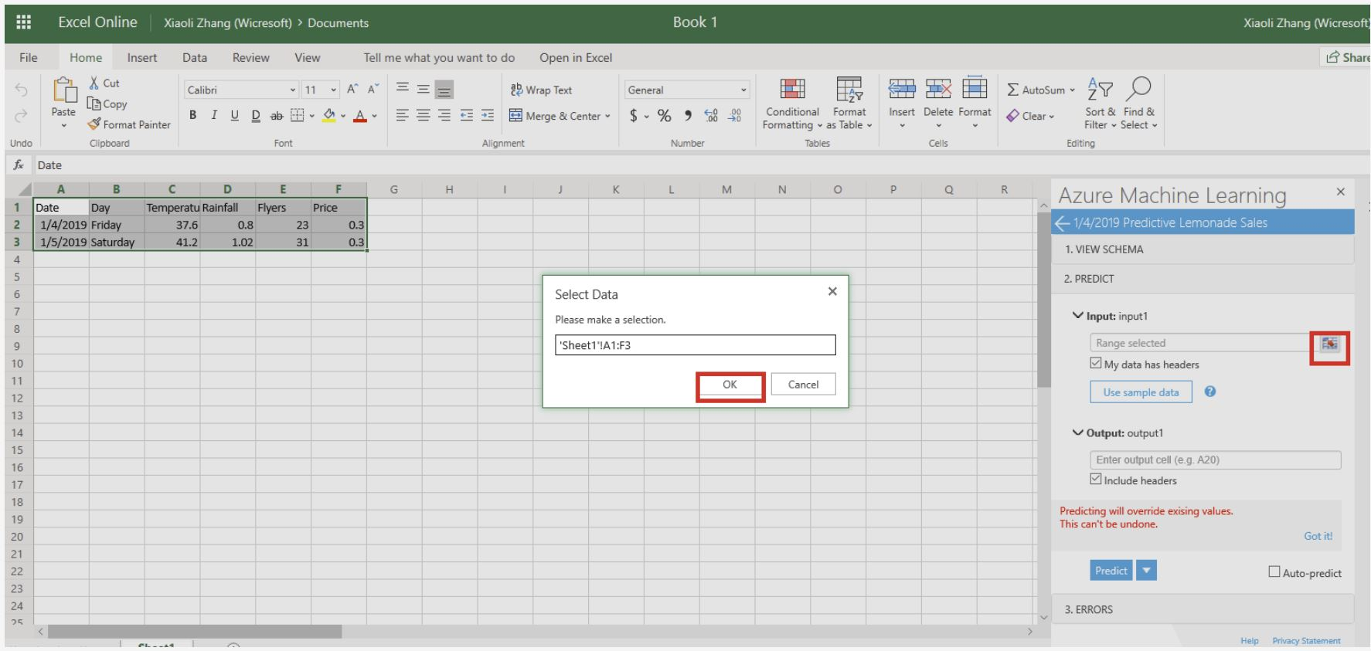

1. In the **Output** box, enter **G1** and ensure that the **Include headers** checkbox is selected as is illustrated here:  
     
   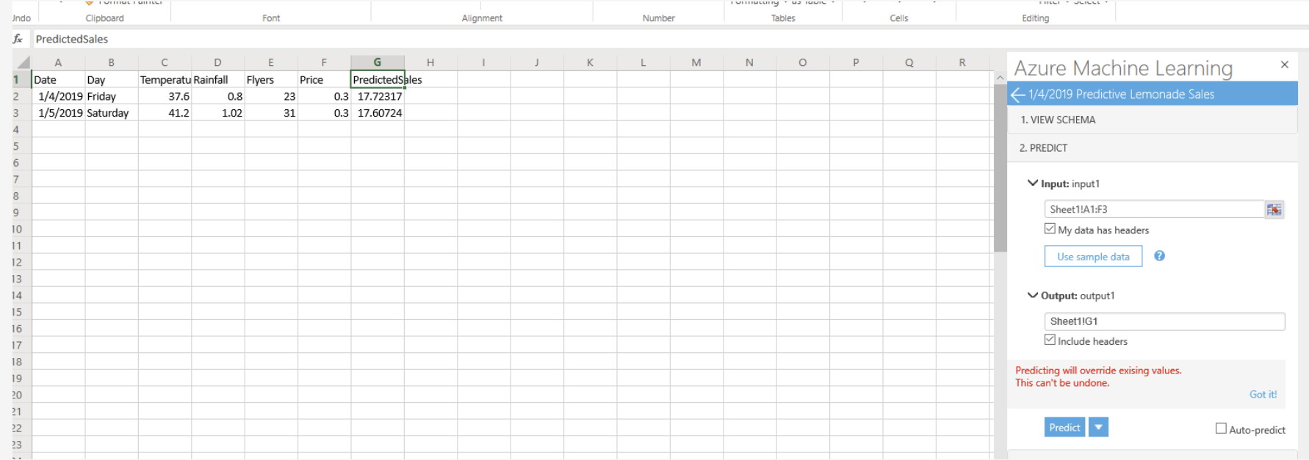
2. Verify that the Azure Machine Learning pane looks like this, and then click **Predict**:

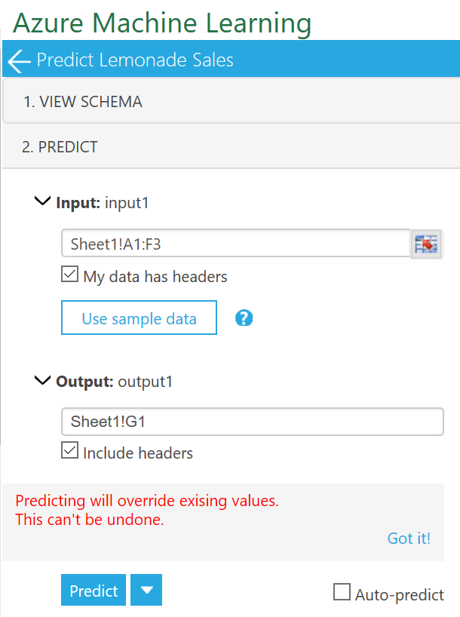

1. Wait for the web service to be called, and then view the **PredictedSales** values that are returned, which should be similar to this:

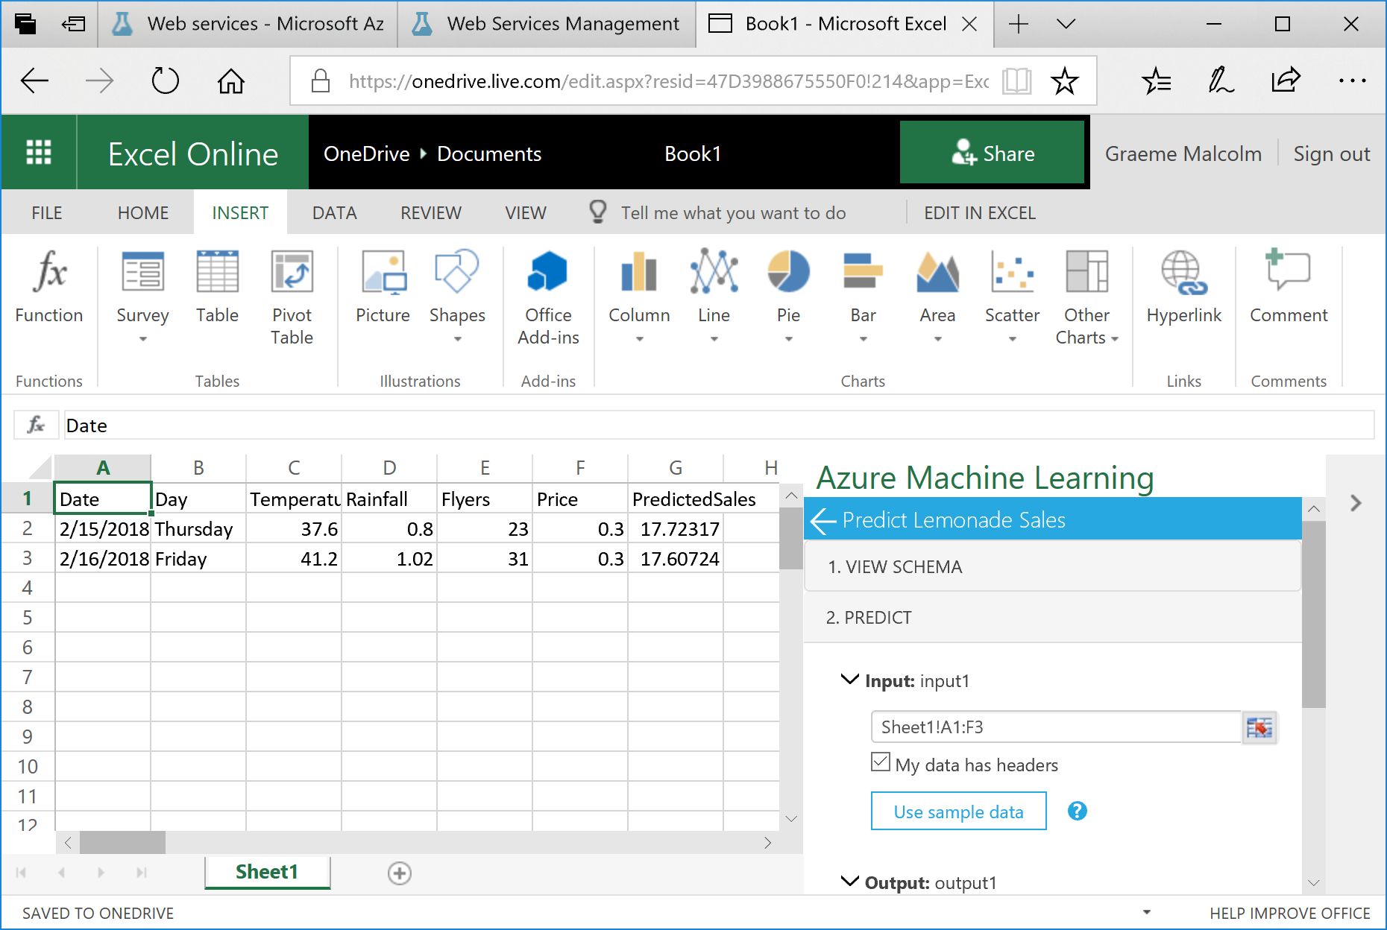

#### Challenge

Try predicting sales for today and tomorrow if Rosie increases the number of flyers to 100.

# Exercise 3: Training a Classification Model

The model you have built to predict daily sales is an example of a regression model. Classification is another kind of supervised learning in which instead of predicting a numeric value, the model is trained to predict the category or *class* of an observation. In this exercise, you will copy an existing training experiment from the Azure AI Gallery and run it to train a classification model that predicts whether or not Rosie will make a profit on a given day.

## Copy an Experiment from the Gallery to your Workspace

1. Navigate to <https://gallery.cortanaintelligence.com/Experiment/Lemonade-Classification>. This opens the **Lemonade Classification** example in the Azure AI Gallery, as shown here:

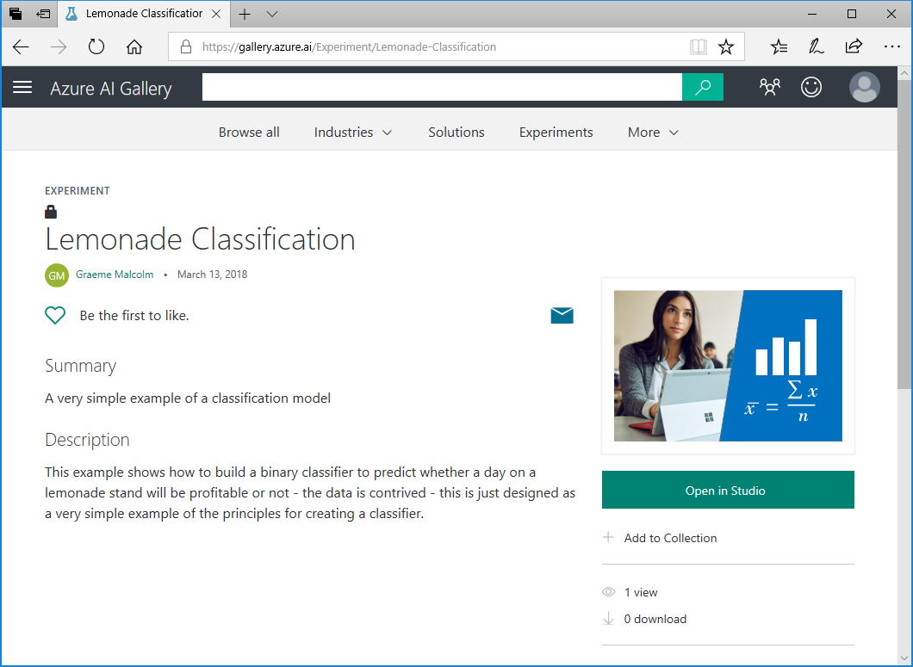

1. Click **Open in Studio** to copy the experiment and its dataset to your Azure Machine Learning Studio workspace. If you are prompted, sign in using your Microsoft account, and then select the region and workspace for your Azure Machine Learning Studio subscription.
2. When the experiment opens in Azure Machine Learning Studio, rearrange the panes and zoom level so you can see the modules it contains. The experiment data flow starts with a dataset named **Profitability.csv**.
3. Visualize the output of the **Profitability.csv** dataset, and note that it contains historic daily lemonade sales data and a column named **Profitable** in which a 1 indicates that Rosie made a profit on that day, and a 0 indicates that the day was unprofitable; as shown here:

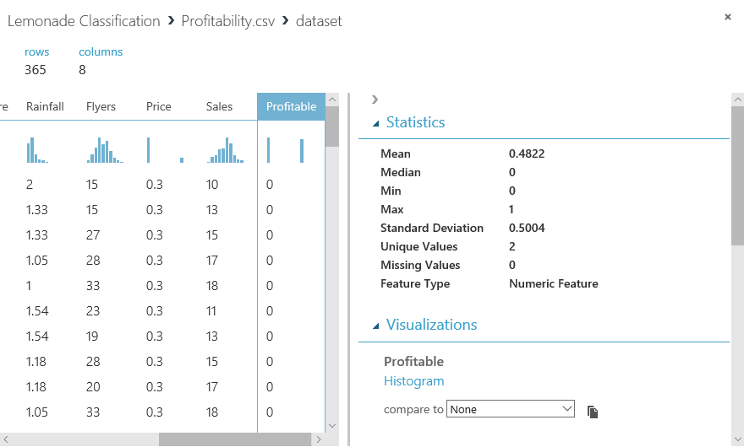

1. Review the rest of the experiment, noting that it contains modules to perform the following tasks:
   * Create a new feature containing the normal log of **Rainfall**.
   * Scale the numeric features using Z-Score or MinMax normalization depending on the distribution of the numeric column data.
   * Mark **Day** as a categorical field.
   * Clear the **Date** and **Rainfall** features.
   * Split the dataset into two subsets for training (70%) and testing (30%).
   * Use the two-class logistic regression algorithm to train a classification model that predicts **Profitable** (in spite of being called “logistic *regression*”, this algorithm is used to predict classes rather than numeric values).
   * Score the trained model using the test data.
   * Evaluate the model based on the test results.

## Run the Experiment and View the Results

1. Run the **Lemonade Classification** experiment and wait for it to complete.
2. When the experiment has finished running, view the output of the **Score Model** module, and note that it contains new fields named **Scored Labels** and **Scored Probabilities** as shown here:

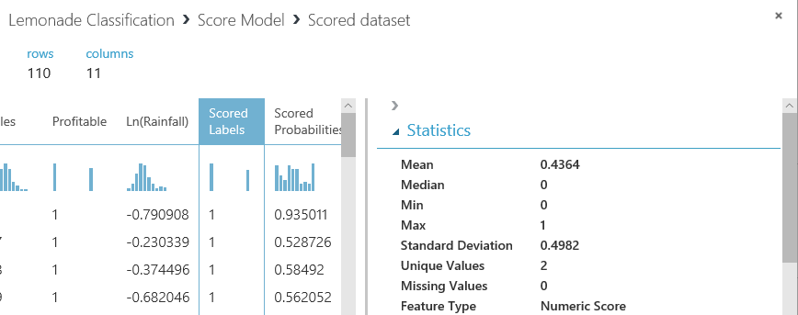

Compare some of the values in the **Scored Labels** field to the **Profitable** field. In most cases, the predicted value in the **Scored Labels** field should be the same as the **Profitable** field.

Compare the **Scored Labels** field to the **Scored Probabilities** field. The scored probability is the numeric value between 0 and 1 calculated by classification algorithm. When this value is closer to 0 than 1, the **Scored Labels** field is 1; and when its closer to 1 than to 0, the **Scored Labels** field is 1.

1. Visualize the output of the **Evaluate Model** module to open the **Evaluation results** window, and view the Received Operator Characteristic (ROC) chart, which should look like this:

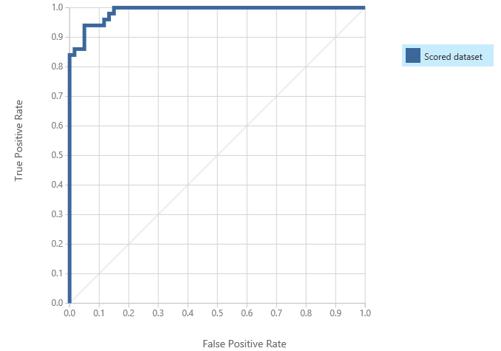

The larger the area under the curve in this chart, the better the model is performing. In this case, the line goes almost all the way up the left side before going across the top, resulting in an area under the curve that includes almost all of the chart.

1. In the **Evaluation results** window, scroll down to view the evaluation metrics, which includes the *confusion matrix* formed by true positive, false negative, false positive, and true negative predictions; the accuracy, recall, precision, and F1 score; the threshold, and the area under the curve (AUC) – as shown here:

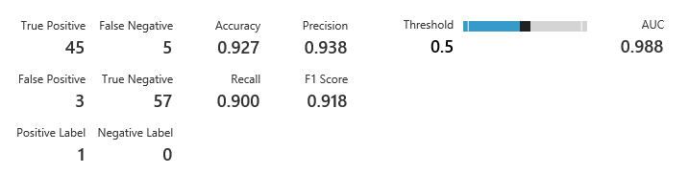

These results indicate that, based on the test data, the trained model does a good job of predicting whether or not a particular day will be profitable.

#### Challenge

Adjust the threshold by dragging the slider, and observe the effect on the model metrics.

# Exercise 4: Training a Clustering Model

So far you have trained two supervised machine learning models: one for regression, and one for classification. Clustering is an example of *unsupervised* learning; in other words, training a predictive model with no known labels. In this exercise, you will copy an existing training experiment from the Azure AI Gallery and run it to train a K-Means clustering model that segments Rosie’s customers into clusters based on similarities in their features.

## Copy an Experiment from the Gallery to your Workspace

1. Navigate to <https://gallery.cortanaintelligence.com/Experiment/Lemonade-Clustering-Customers>. This opens the **Lemonade - Clustering Customers** example in the Azure AI Gallery, as shown here:

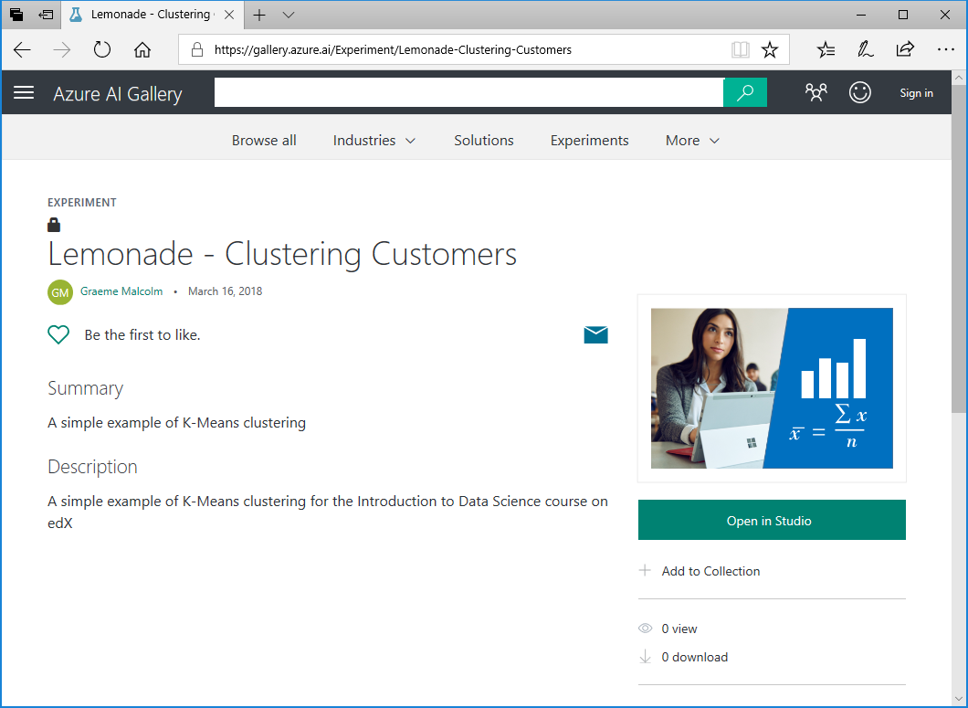

1. Click **Open in Studio** to copy the experiment and its dataset to your Azure Machine Learning Studio workspace. If you are prompted, sign in using your Microsoft account, and then select the region and workspace for your Azure Machine Learning Studio subscription.
2. When the experiment opens in Azure Machine Learning Studio, rearrange the panes and zoom level so you can see the modules it contains. The experiment data flow starts with a dataset named **Customers.csv**.
3. Visualize the output of the **Customers.csv** dataset, and note that it contains observations for 109 customers, including the following features:
   * **CustomerID**: A unique identifier for each customer.
   * **Name**: The customer’s full name.
   * **Age**: The age of the customer.
   * **AvgWeeklySales**. The average number of sales to this customer per week.
   * **AvgDrinks**: The average number of drinks purchased by this customer per sale.
4. Review the rest of the experiment, noting that unlike the supervised learning experiments you have conducted previously, there is no step to split the data and withhold a set for testing. This is because in an unsupervised learning model, there is no known label with which to test the predictions.
5. Select the **K-Means Clustering** module and view its settings in the **Properties** pane as shown here:

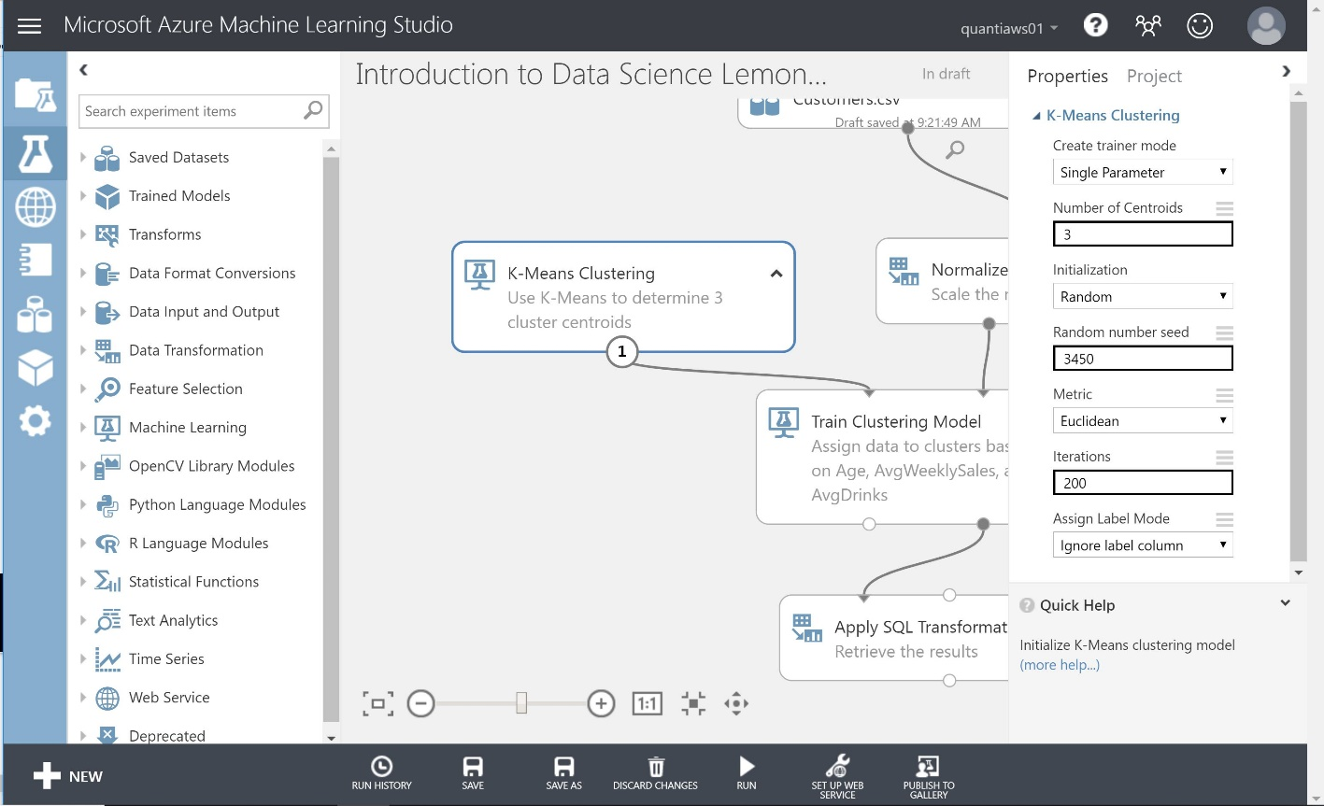

Note that the K-Means clustering algorithm is configured to initialize 3 random centroids, and then perform 200 iterations of assigning observations to their nearest centroid and then moving the centroid to the middle of its cluster of observations.

## Run the Experiment and View the Results

1. Run the **Lemonade – Clustering Customers** experiment and wait for it to complete.
2. When the experiment has finished running, visualize the **Results dataset** (right) output of the **Train Clustering Model** module to view the Principle Component Analysis (PCA) visualization for the results, which should look like this:

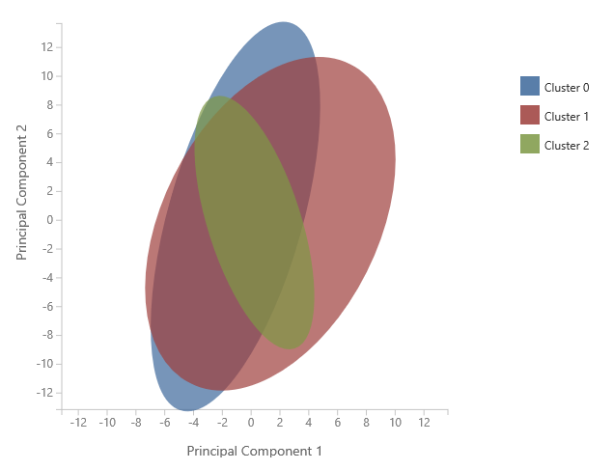

The PCA ellipses for the clusters are all oriented in different directions, indicating that there is some separation between them – though clusters 0 and 1 are not as well separated as clusters 1 and 2.

1. Visualize the output of the **Apply SQL Transformation** module at the end of the experiment, and note that it contains the following new fields:
   * **Assignments**: The cluster to which this observation has been assigned (0, 1, or 2).
   * **DistancesToClusterCenterno.0**: The distance from this observation to the center of cluster 0.
   * **DistancesToClusterCenterno.1**: The distance from this observation to the center of cluster 1.
   * **DistancesToClusterCenterno.2**: The distance from this observation to the center of cluster 2.

Each observation has been assigned to the cluster to which it is closest.

#### Challenge

Note the **Assignments** value indicating the cluster to which customer 1 (Marva Cardenas) is assigned.